GREENLAWNS SCHOOL, WORLI
TERMINAL EXAMINATION: 2019-20
SCIENCE
Std: V Marks: 80
Date: 30/09/2019 Time: 2 hrs
Carefully read this paper in the first ten minutes. Your answers should be concise and contain scientific terms. All answers have to be written on the answer script.

Q.1) Name the following: [6]
- Materials which allow only some light to pass through them.
- Practice of cutting down trees and removing vegetation from a forest area for farming and other human activities.
- A very strong and powerful wind with rain.
- The joint which allows us to move our head sideways.
- A simple machine made up of a wheel rigidly attached to a rod.
- A long flat bone present in the centre of the chest.

Q.2) Fill in the blanks: [6]
- The muscles remain attached to the bones through __________
- When two liquids completely mix with each other, they are called __________ liquids.
- A pulley consists of a wheel with a __________ rim and a rope.
- The process of breaking down complex nutrients into simpler substances by decomposers is called __________
- A shadow is always formed on the __________ side of the light.
- __________ is a state of matter with a lot of space between the particles.

Q.3) State whether the following statements are true or false. If false, rewrite the correct [5]
statement:
- Oxygen is the most abundant gas present in the air.
- Pollution causes land and water to become poisonous for living organisms.
- The hip girdle is made up of two bones fused to form a single bone.
- The revolution of Earth causes the formation of day and night.
- A class-two lever has load located between the fulcrum and the effort.

Q.4) Give two examples of each: [5]
- Scavengers
- Class-three lever
- Insoluble substances
- Foods rich in vitamin C
- Location of voluntary muscles

Q.5) Define the following: [5]
- Humidity d) Food chain
- Cartilage e) Inclined plane
- Decantation

Q.6) Give one point of difference between the following: [5]
- Total and partial lunar eclipse
- Smooth and cardiac muscles
- Solute and solvent
- Load and fulcrum
- Consumers and decomposers

Q.7) Give reasons for the following:
- Liquids flow. [1]
- The revolution of the Earth is important. [1]
- A scissor is an example of class-one lever. [1]
- We must include food items that are rich in proteins in our diet. [2]
- All plants and animals are essential to maintain the balance in nature. [2]

Q.8) Answer in short: [14]
- Mention and two properties of air.
- List two ways in which plants depend upon animals.
- What is the function of the vertebral column? How many bones is vertebral column made of?
- Why are ventilators generally located at the top portion of the walls of rooms?
- Write any two reasons why muscles are important.
- On what does the size and clarity of the shadow depends on?
- What is land breeze?

Q.9) Answer the following diagram based questions:
- The figure below represents a method of separation of substances. Observe and answer the questions:

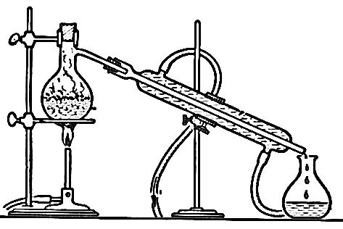
1) Name this method of separation. [1]
2) Give one example of a mixture separated by this method. [1]
3) Name another method which can separate mixture mentioned
by you in the above answer. [1]
4) What is the liquid collected in receiver called? [1]
5) Where can the liquid mentioned by you above be used? [1]

- The diagram below represents a type of eclipse. Observe and answer the questions:
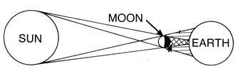

- What is an eclipse? [1]
- Identify the eclipse shown in the diagram above. [1]
- Explain the two types of the eclipse mentioned by you above. [2]
- How must such an eclipse be viewed and why? [2]

- The figure below represents a major bone of the skeleton system. Observe and answer:

- Of how many bones is this structure made of? [1]
- What is the function of this structure? [1]
- Which is the only movable part of this structure? [1]
- Which joint helps to move this structure? [1]
- State any two functions of bones in the human body. [2]

Q.10) Write short notes on:
- Monsoon breeze [3]
- Ball and socket joint [3]

Q.11) Draw neat and labelled diagrams of the following:
- Sea breeze [2]
- Any two examples of class –three lever [2]

******

