GREENLAWNS SCHOOL, WORLI
TERMINAL EXAMINATION-2019
SOCIAL STUDIES
Std : V Marks: 80
Date: 26/9/19 Time: 2Hrs
1. Read all questions carefully.
2. All questions are compulsory.

QI Fill in the blanks: (10)
- Domestication began in the ________ Age, when man learnt to grow crops and tame animals.
- The invention of wheel was a remarkable invention of the _________ man.
- Dr. B. R. Ambedkar was called as the ‘___________’ for preparing a draft of our constitution.
- Elections are the backbone of Indian ____________.
- The area between 0٭E and 180٭ E is called the ______ _.
- A __________ is a violent storm.
- The condition of extreme shortage of water for agriculture and domestic use is called __________.
- _________ crops are the crops grown to be sold in the market.
- India is one of the largest producers of ______ ______ in the world.
- Farmers _________ their crops at the right time with the right amount of water.
QII Name the following: (10)
- Two main colours used by the Mesolithic man:
- Two civilizations of the Iron Age:
- Two names given to the period following the Mesolithic Age:
- Two famous political parties of India:
- Two names given to full circles which run from east to west on the globe:
- Two rivers which flood every year in India:
- Two drought resistant crops:
- Two winter vegetables:
- Two states of India where spices are mostly grown:
- Two common insecticides:
QIII State whether the following statements are true or false. If false, correct and rewrite the correct statement: (6)

- Iron tools were used widely during the Neolithic Age:
- The Egyptian Civilization belonged to the Chalcolithic Age:
- The Parliament announces the Election dates:
- The Pacific Ocean is the most important longitude which divides the earth into eastern hemisphere and western hemisphere:
- The deserts in the northern part of India experience frequent earthquakes:
- Many multi – purpose projects have been built to supply water for medical facilities:

QIV Match the following: (5)
A | B
- Neolithic man | 1. Rice
- Terracotta | 2. Fishing
- Secular | 3. India
- Abraham Lincoln | 4. Natural Disasters
- Equator | 5. Study of Earthquakes
- Seismology | 6. Longest Parallel
- Violent Natural Occurrences | 7. Father of Democracy
- An agricultural country | 8. No state religion.
- Important food crop of India | 9. Settled in safe comfortable houses.
- Main occupation of the coast | 10. Reddish bakes clay

QV Define the following terms: (5)
1. Domestication:
2. Constitution:
3. Model Code of Conduct:
4. Epicenter:
5. Irrigation:

QVI Answer the following: (1mk each) (10)

1. What were the benefits of farming and herding?
2. When did India become Republic?
3. What is the duty of the Election Commissioner?
4. How does a Tsunami occur?
5. How do the armed – forces help the people in disaster affected areas?
6. What is the Great Circle?
7. How is the intersection useful to us?
8. Which soil is best for Jute production?
9. What is the first preparation for growing crops?
10. Which type of climate is essential for growing oilseeds?

QVII Answer the following questions: (2mk each) (10)
1. State the importance of Iron weapons during the Iron Age?
2. What is the significance of the International Date Line?
3. How are elections in India conducted? Why is this process popular?
4. What precautions should be taken during extreme floods? (any2)
5. Why is manure fertilizer preferred by the farmers?

QVIII Answer the following questions in brief: (3 mks each) (6)
- How do campaigning for elections in India takes place?
- Write in brief about the Properties of the Longitudes with reference to the Meridians. (3 points only)
QIX Distinguish between the following terms: (2 mks each) (6)
1. Sovereign and Socialist.
2. Axis and Grid.
3. Kharif and Rabi Crops.

QX With reference to the picture given below, answer the questions that follow: (6)
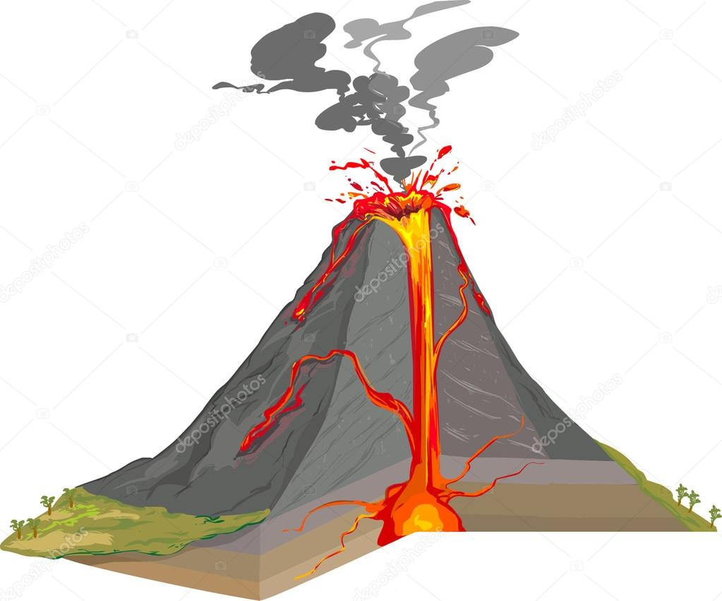
- Identify the above given picture and label the given arrows. (2)
- Mention any two ways of precaution that one should take, when we experience the above natural phenomenon. (2)
- Explain the Extinct phenomenon with an example. (2)

QXI Identify the Right a person is entitled to in situations given below: (3)
1. Ms Neha wants to give up her dentistry and join politics.
2. Mr. Salman wants to go to the High court as he feels that the verdict given by the Subordinate Court is not in his favour.
3. Mary asks her man – servant to put his daughter to a school so that she may be educated.

QXII Draw, colour and label the diagram of The Parallels of Latitude: (3)

