GREENLAWNS SCHOOL, WORLI
TERMINAL EXAMINATION: 2019-20
BIOLOGY
Std: VIII Marks: 80
Date: 23/09/2019 Time: 2 hrs
Answer to this paper must be written on the answer booklet provided to you. The first 10 minutes are to be spent in reading the Question paper. The time given at the head of this paper is the time allowed for writing the answers. All questions are compulsory.
Do not waste paper. Leave only one line after each answer.

I A) Name the following: [5]
- Another name for involuntary actions.
- A dual purpose breed of cow.
- A cluster of hormone secreting cells of pancreas.
- The female reproductive part of a flower.
- The pressure developed in the root due to continuous inflow of water because of cell-to-cell osmosis.

B) Fill in the blanks: [5]
- Potato bears vegetative buds called the ___________
- The hormone ___________ raises the sugar level in the blood.
- Crops cultivated for commercial purposes are called ___________ crops.
- The sensation travelling through the nerve is the ___________
- Transpiration is reduced if the air is ___________

C) State whether the following statements are true or false. If false, write the correct statement: [5]
- Insect-pollinated flowers produce a large quantity of pollen which are light.
- Curing of tea is done with the help of fungi.
- The age of a tree can be determined by counting the number of rings.
- Association neurons transmit impulses from one neuron to another.
- Asparagus reproduces by stem.

D) Explain the following terms: [5]
- Synapse iv. Pollination
- Hormone v. Transpiration
- Aquaculture

E) Give two examples of each: [5]
- Spore formation in plants iv. Conditioned reflexes
- Wind pollination in plants v. Micro-nutrients for plants
- Ornamental plants

F) Give one difference between the following pairs on the basis of what is indicated in the bracket.
Answer only in tabular form. [5]
- Boys and girls (changes during puberty)
- Male and female (hormones)
- Phosphorus and potassium (role in plant)
- Bacon and ham (part of the pig body)
- Spinal nerves and cranial nerves (total number)

G) Give scientific reasons for the following: [5]
- Injury to the medulla oblongata may result in the death of a person.
- Sea food is highly nutritious.
- Standing under a tree during a hot summer midday, gives us a cooling effect.
- The pituitary gland plays an important role in the birth process.
- Farmers prefer to grow certain crops by vegetative method.

H) Give one function of each of the following: [5]
- Phloem iv. FSH
- Yeast v. Spinal cord
- Calyx

II A) Given below is the diagrammatic sketch of an endocrine gland. Observe the figure and answer
the following questions:
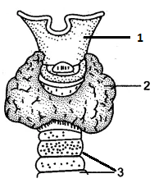
- Label the parts 1, 2 and 3. [1½]
- Name the hormone secreted by part 2. [½]
- Give one important function of part 2. [1]
- Mention three ailments caused due to insufficient secretion of part [3]
2 with one symptom of each.
- Name the element related with the functioning of part 2. [½]
- What does oversecretion of 2 cause? [½]

B) Write a short note on Kharif crops. [2]
C) Define adolescence. [1]

III A) ‘Poultry farming is a profitable business with a small investment.’ Now answer the following
questions with regards to poultry farming.
- What are broilers and layers? [1]
- Describe the feed given to poultry birds. [2]
- Which is the indigenous poultry breed of India? [½]
- Which is the exotic poultry breed developed on a farm in USA? [½]

B) What are the benefits of doing Yoga? [2]
C) The figure below represents a type of cross pollination. Observe and answer the following
questions:
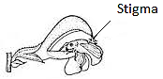
- Give any two characteristics of such a type of pollination. [2]
- Name two flowers pollinated by this method. [1]
- Distinguish between unisexual and bisexual flower. [1]

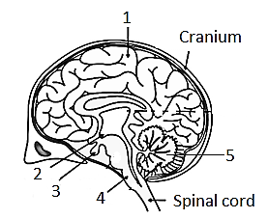
IV A) The figure below shows brain in median section:
- Name parts 2 and 4. [1]
- Give functions of any two hormones of part 3. [2]
- State the functions of part 1 and 5. [2]
- How is the arrangement of neurons in part 1? [1]
- Define nerve. [1]
- Draw a neat and labelled diagram of a neuron. [3]

V A) The figure below is the diagrammatic representation of the nature of a semi-permeable
membrane. Observe and answer the questions that follow:
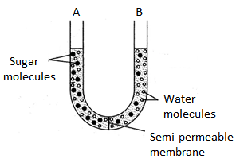

- Which side of the membrane is a dilute solution and which is a concentrated one? [1]
- Draw a neat diagram of the observation that you will notice after a while. [1]
- Define the phenomenon which causes the change. [1]
- What is active transport? [1]

B) How does Insulin lowers glucose from the blood stream? [3]
C) Which two systems are antagonistic in their actions? What is their effect on our body? [2]
D) Why do young people get acne and pimples on the face? [1]
******

