GREENLAWNS SCHOOL, WORLI
Terminal Examination 2019
COMPUTERS

STD: VIII Marks: 80
DATE: 16.09.2019 TIME: 2 hrs.
Instructions:
- All questions are compulsory.
- All questions carry equal marks.
- Draw neat and well labelled correct diagram wherever necessary.
- Write only answers with proper sub-question numbers.
- Only first attempt will be evaluated for objectives.
- Figures to the right indicate full marks.

Q1. Fill in the blanks: [5]
- The process of drawing a flowchart for an algorithm is known as __________.
- A range is a group of ____________ cells, which form the shape of rectangle.
- The ability to perform more than one task together at one time is called _____________________.
- The set of instruction written in stepwise sequence is called ____________.
- The _____________ is one of the options in the function library group which helps to create a formula.
Q2. Write true or false for the given statements; if false, write the correct
statement. [5]
- An Algorithm is written in English language.
- Formulas are the user defined instructions to perform calculations.
- Hardware refers to the instructions or programs that tell the hardware what to do.
- Addition of two or more text values is called functions.
- Windows 98 was the first operating system to support Internet connection sharing.

Q3. Match the column. [5]
1. SUM (range) | a. Multiplies the values in a range
2. PRODUCT (range) | b. Rounds a number to the nearest  integer.
3. INT (number) | c. Rounds a number to the specified  digits.
4. EXP (number) | d. Gives the sum of a range.
5. ROUND (number,num_digit) | e. Returns (natural logarithm) raised to  the power of a number.

1
Q4. Write short note on the following.
- System Software [2]
- Mixed Reference [2]
- AutoSum [2]
- Security and protection [2]
- Enforcement of priority system [2]

Q4. Answer the following question:
- Write down the steps using cell reference to copy-paste an option to another worksheet. [3]

- Write down the steps to calculate MAX ( ). [3]
- What are the rules to enter a function? [3]
- Write down the steps to insert compound formula. [3]
- Make a flowchart to calculate the sum, difference, and product of two numbers. [3]

Q5. Answer in brief:
- Write the features of a flowchart. [4]
- Write disadvantages of flowchart. [4]
- Write any four characteristics of an algorithm. [4]
- Elements of formulas in Excel. [4]

Q6. Application based question: [4]
- While conducting a lecture on the types of operating system, Siri’s instructor asked him to name an operating system that is used when the time span required to react to an input is rigid and time bound. Can you help Siri in answering the question?
- In a quiz competition, the quiz master asked one of the participants, Neha, “In which user interface, the user mostly gets immediate visual feedback of the action he performs?” To this Neha replied “CUI”, Is she right? If not, what is the right answer?
- A sports teacher has measured the height of the students in a class. Suresh has given the assignment to find the maximum and minimum height from the collected data. Suggest the function, which she should use to accomplish the task.
- Ms Sehrish and her friend got a raise to 10% in their salaries. Find the total amount if their present salary is ₹ 15,000. Calculate the salary by using the formula.

2

Q7. Identify the common errors while inserting a formula and state a reason:
[5]
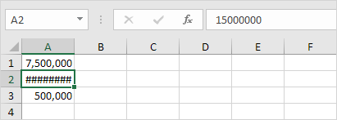

b)
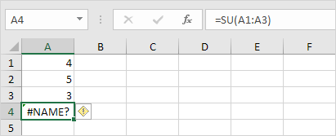

c)
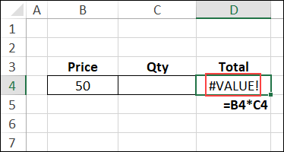

d)
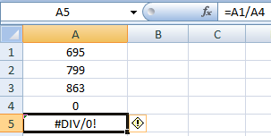

e)
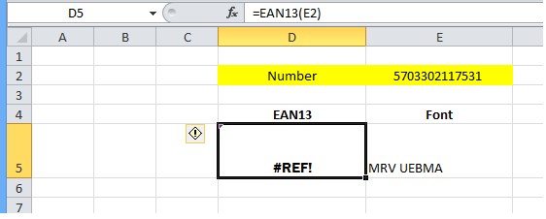

3

Q8. Write an algorithm and make a flowchart to check whether a number is
even or not. [5]
Q9. Write an algorithm and make a flowchart to swap two numbers. [5]

Q10. Draw the flowchart symbols for the following: [5]
- Start
- Input A,B
- Is A>B
- Stop
- Print A

4

