GREENLAWNS SCHOOL, WORLI
TERMINAL EXAMINATION – 2019
ENGLISH LANGUAGE

Std : VI Marks : 80
Date: 26/09/19 Time : 2 Hrs
NOTE: 1) Attempt all four questions in the same sequence as given in the question paper.
2) Section IV must be attempted on the question paper itself. This section must
be detached and attached to the answer booklet

SECTION I
COMPOSITION
Q.I] Write a composition of about 200-250 words on any ONE of the following.
You must use at least five words from the given word-bank. Do not change
the tense or form of the words given in the word-bank. (20)

- You woke up one morning and found yourself in a country you have never
visited before. Write an essay, describing the special features of your new
surroundings.
Word Bank: magical – fairytale – tourist – wandered – historical – food stalls –
captivating – culture – sense of belonging – discovery.

- One day your father decided to take you to his work place for a day. Write a
narrative essay, highlighting how you spent your day at your father’s office.
Word Bank: organised – laptop – receptionist – friendly – employee – errands –
elevators – assistant – security guard – chairman.

- Complete the story titled ‘The Lion King’ by providing a twist to the outline given
below:
lion – king of the jungle – son – tempted by his uncle – alone – deep valley –
chased by animals – father’s death – son is sent away – uncle rules the
kingdom – return of the son – uncle is killed – son rules the kingdom.

(d) Study the picture given below. Write a story about what the picture suggests to
you. There must be a clear connection between the picture and the composition.

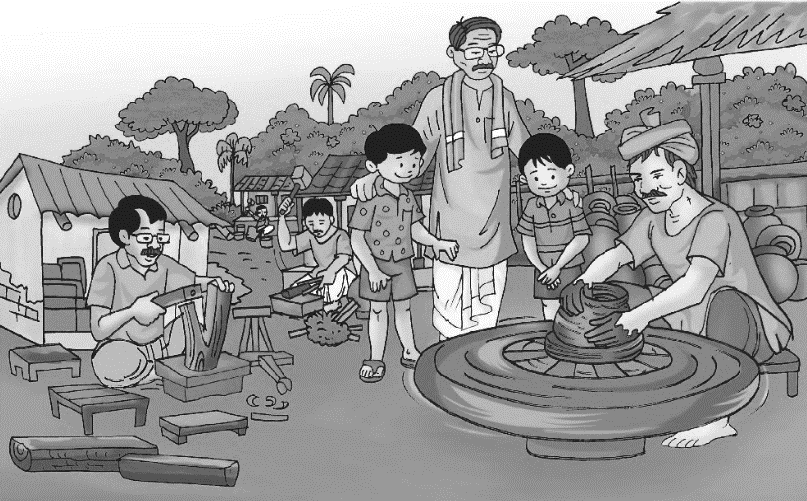
SECTION II
LETTER
Q II] Select any ONE of the following: (10)
- You had a fight with your best friend and you decided that you will never talk to
each other again, but later you decided to make up. Write a letter to your friend,
apologising for your behaviour and mentioning the reasons why you were upset.
You must mention a few ways in which your friend and you can resolve fights in
the future.

- Your class organised the Canteen Day for the school. Write a letter to your
grandfather, telling him about the event. Your letter must include your efforts
on the Canteen Day and the importance of having such an event for school
students.

SECTION III
COMPREHENSION

Q III] Read the passage given below and answer the questions that follow: (20)

It was the first day of spring, but here in the Himalayas it still seemed
like mid-winter. A cold wind hummed and whistled through the pines, while
dark rain clouds were swept along the sky. I was climbing the steep road to
my cottage at the top of the hill when I was overtaken by nine-year-old Usha
hurrying back from school. She had tied a scarf around her head to keep her
hair from blowing. Her dark hair, black eyes and pink cheeks could be seen
all the more clearly because of the patches of snow still lying on the hillside.
“Look,’ she said, “A new flower!”
It was a single, butter-yellow blossom and it stood out like a bright star
against the dull winter grass. I had not seen anything like the flower before
and had no idea what its name might be. This beautiful flower was a new
discovery for me. “Shall I pluck it for you?” said Usha. “No, do not,” I said.
“It may be the only one. If we pluck it, there may not be any more. Let us
leave it and see if it seeds.”
We scrambled up the slope and examined the flower more closely.
It was very delicate and soft-petalled, looking as if it might fall at any moment.
“It will be finished if it rains,” said Usha. It did rain that night – rain mingled
with hail. The rain rattled and swished on the tin roof; but in the morning the
sun came out. I walked up the road without really expecting to see the
flower again. I realised that Usha had been right. The flower had disappeared
in the storm. However, two other buds, unnoticed by us the day before, had
opened. It was as though two tiny stars had fallen to Earth in the night.
I did not see Usha that day; but the following day when we met on the
road, I showed her the fresh blossoms. They were still there, two days later,
when I passed by; but so were two goats, grazing on the short grass and
thorny thickets of the slope. I had no idea if they were going to be kind to these
particular flowers, but I did know that goats would eat almost anything and I was
taking no chances. Scrambling up the steep slope, I began to shoo them away.
One goat retreated, but the other lowered its horns, gave me a threatening
look and refused to move.
At that moment, Usha came along and, understanding the situation,
came to the rescue. She unfurled her pretty blue umbrella and advanced on
the goat shouting at it in goat-language. The beast retreated and the flowers
were saved. As the days grew warmer, the flowers faded and finally
disappeared. I forgot all about them and so did Usha. There were lessons
and exam for her to worry about, and rent and electricity bills to occupy my
thoughts. The months passed; summer and autumn came and went, with
their own more showy blossoms; and in no time at all, winter returned with
cold winds blowing from all directions.
One day I heard Usha calling to me from the hillside. I looked up and
saw her standing behind a little cluster of golden, star-shaped flowers. This
was an enchanting sight for me as I had played a small part in making sure
they lived. Where there had been one flowering plant, there were now several.
Usha and I speculated on the prospect of the entire hillside being covered
with the flowers in a few years’ time.
I still do not know the scientific name for the little flower. Usha told me
that she has seen it growing near her father’s village on the next mountain

and that the villagers call it ‘Basant’, which means spring. Although I am just
a little disappointed that we are not, after all, the discoverers of a new
species, this disappointment is overcome by the pure pleasure in knowing
that the flower flourishes in times of difficulty.

- How has the narrator described the contrast in the Himalayan climate? (2)

2) Highlight the narrator’s thoughts on seeing the flower for the first time. (2)

3) Why was the flower considered to be fragile by the narrator and Usha? (2)

4) In what way did the rain enhance the appearance of the flowering plant? (2)

5) What were the two goats doing near the plant? Why did the narrator wish
to protect the plant? (3)

6) How did Usha save the narrator and the plant from the goat? (1)

7) Why did the narrator and Usha fail to remember the plant they had seen? (1)

8) Apart from the slope, where had Usha seen the plant grow? What was
fascinating about its name? (2)

9) What message does the narrator convey when he mentions the phrase ‘the
flower flourishes in times of difficulty'? (1)

10) Find words from the passage that mean the same as the following: (2)
i) uphill –
ii) revelation –
iii) relief –
iv) bunch –

11) Find words from the passage that mean the opposite of the following: (2)
i) separated –
ii) advanced –
iii) ignored –
iv) contented –

Std: VI
Date: 26/09/19
Name: ________________________________________________ Roll no: ________

SECTION IV
GRAMMAR – 30 MARKS

Q I] Fill in the blanks with suitable articles. (1)

- Mike walked through the orchard. He plucked ____________ orange from the

tree and tasted _________________ juicy fruit.

Q II A] Replace the meanings with the correct idioms in the sentences given below: (1)

- Brad ate a lot after he returned home from the school picnic.

_____________________________________________________________

_____________________________________________________________

- Nikita’s nephew revealed the secret by mistake, about her surprise birthday
party.

______________________________________________________________

______________________________________________________________

B] State the meaning of the following proverbs: (2)

- Empty vessels make the most noise – ________________________________

_______________________________________________________________

_______________________________________________________________

_______________________________________________________________

- Better late than never – ____________________________________________

_______________________________________________________________

_______________________________________________________________

_______________________________________________________________

Q III A] Write the possessive form of the following: (1)

- The wages of the tailors – __________________________________________

- The toys of the baby – _____________________________________________

B] Fill in the blanks with abstract nouns. (1)

- Mina’s parents were filled with _________________ (proud) when she received
her award.

- The kind gentleman offered some _________________ (feed) to the beggar.

C] Rewrite the sentence using the correct collective noun: (1)

- Nancy found a collection of arrows in the garden of the castle.

________________________________________________________________

________________________________________________________________

- The case was presided over by a number of judges in the court.

________________________________________________________________

________________________________________________________________

D] Change the singular nouns into their plural form. You must make any other
changes, if needed: (1)

- The tiger was chasing the helpless deer.

_______________________________________________________________

_______________________________________________________________

- People find cactus in the Mexican Desert.

______________________________________________________________

______________________________________________________________

E] Change the gender of the underlined nouns: (1)

1) The peacock started dancing as soon as it began to rain.

______________________________________________________________

______________________________________________________________

2) The young heiress inherited an enormous bungalow.

______________________________________________________________

______________________________________________________________

Q IV] Punctuate the following sentence: (2)
1) the sea was rough However we made the crossing without being seasick

_______________________________________________________________

_______________________________________________________________

Q V] Identify the underlined pronouns: (2)

1) This is a book on rare plants.

_________________________________________________________

2) Jatin said that the badminton racquets were his.

__________________________________________________________

3) Tommy’s mother sat by herself in the park and read a book.

__________________________________________________________

4) People who are cruel to animals must be punished.

__________________________________________________________

Q VI] Join the sentences using the conjunction given in the brackets: (2)

- Jen wanted to see the magic show. Her mother purchased the tickets. (so)

______________________________________________________________
______________________________________________________________

______________________________________________________________

- Meera packed sunglasses . Meera packed sunscreen for the trip. (both…and)

______________________________________________________________

______________________________________________________________

______________________________________________________________

Q VII A] Underline the verbs and state whether they are transitive or intransitive
verbs: (2)

- Jim wore his winter boots because it was cold.

______________________________________________________________

- Tanya watched the dolphin show at the amusement park.

______________________________________________________________

B] Rewrite the sentences by using the correct auxiliary verb or modal: (2)

1) Would I borrow your umbrella?

______________________________________________________________

2) Drivers could stop when the traffic light is red.

_______________________________________________________________

- When Rajiv was just three years old, he should play the piano.

_______________________________________________________________

_______________________________________________________________

- The children is swimming in the lake.

_______________________________________________________________

Q VIII] Fill in the blanks with the correct form of the verb given in the brackets: (3)

- Sonia ____________________________ (learn) how to dance every Tuesday.

- Charles Babbage ______________________ (invent) the computer in 1822.

- Nelson _________________________ (paint) when his science teacher entered
the classroom.

- By tomorrow morning, Anuja __________________________ (land) in Germany.

- After twenty minutes, Mariam ______________________ (practice) Mathematics
for two hours.

- Anurag ______________________ (clean) his wardrobe every Saturday morning.

Q IX] Do as directed: (4)

1) The feeble man walked out of the hospital with his family. (Underline the Adjective
of Quality)

2) ________________ recipe did you choose while baking the cake? (Fill in the blank
with an interrogative adjective)

- There were silk, five, elegant, new dresses on sale. (Arrange the adjectives in the
correct order)

_________________________________________________________________

_________________________________________________________________

_________________________________________________________________

- Dehradun is cooler than the other neighbouring cities. (Change to the positive
degree)

_________________________________________________________________

_________________________________________________________________

_________________________________________________________________

- No other child in the class is as clever as Ved. (Change to superlative degree)

_________________________________________________________________

_________________________________________________________________

Q X A] Fill in the blanks by choosing the correct preposition from the brackets: (2)

1) Inspecter Das is talking _____________________ (with/to) the Chief of Police.

2) The boys are standing _____________________ (over/under) the bridge.

3) The car is parked __________________________ (in front of/through) the
garage.

4) The bus crashed _________________________ (into/in) a road block.

B] Make sentences using the following phrasal verbs: (2)

1) come from (somewhere) – __________________________________________

________________________________________________________________

________________________________________________________________

2) get around – _____________________________________________________

________________________________________________________________

________________________________________________________________

-----------------xxxxxxxxxxxx----------------

