GREENLAWNS SCHOOL, WORLI
FIRST TERMINAL EXAMINATION
Std. 7 ENGLISH LANGUAGE Marks: 80
Date: 20.09.19 Time : 2 Hours
- Write a composition of not more than 300 words on any one of the following topics: [15]
- ‘Words break no bones, but they do break hearts.’ Describe an incident or incidents which bring out clearly the truth of this maxim.
- You met an unusual person recently. Describe the person, where the meeting took place, what happened and the impact it has had on you.
- Write a shot story that begins with the following lines: The house was in darkness when Maya reached home. Fear clutched her heart as she tried to peer through the window….
- Study the picture given below. Write a story or a description or an account of what it suggests to you. Your composition may be about the subject of the picture or you may take suggestions from it but there must be clear connection between the picture and your composition.

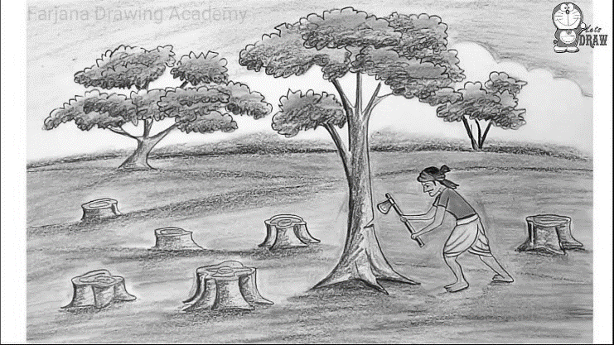

- Select any one of the following topics: [10]
- Write a letter to your younger brother/sister advising him/her to read the newspaper regularly, impressing upon him/her the need for doing so.
OR
- While your aunt next door is on a holiday, someone has broken into her house and stolen various things. Write a letter to your aunt explaining what has happened, advising her what to do.
- Read the following passage carefully and answer the questions that follow: [25]
As Gregor Samsa awoke one morning from uneasy dreams, he found himself transformed in his bed into a gigantic insect. He was lying on his hard, as it were armor-plated, back and when he lifted his head a little he could see his dome-like brown belly divided into stiff arched segments on top of which the bed quilt could hardly keep in position and was about to slide off completely. His numerous legs, which were pitifully thin compared to the rest of his bulk, waved helplessly before his eyes.
What has happened to me? he thought. It was no dream. His room, a regular human bedroom, only rather too small, lay quiet between the four familiar walls. Above the table on which a collection of cloth samples was unpacked and spread out (Samsa was a commercial traveller) hung the picture which he had recently cut out of an illustrated magazine and put into a pretty gilt frame. It showed a lady, with a fur cap on and a fur stole, sitting upright and holding out to the spectator a huge fur muff into which the whole of her forearm had vanished! Gregor's eyes turned next to the window, and the overcast sky-one could hear raindrops beating on the window gutter-made him quite melancholy. What about sleeping a little longer and forgetting all this nonsense, he thought, but it could not be done, for he was accustomed to sleep on his right side and in his present condition he could not turn himself over. However violently he forced himself towards his right side he always rolled on to his back again. He tried it at least a hundred times, shutting his eyes to keep from seeing his struggling legs, and only desisted when he began to feel in his side a faint dull ache he had never experienced before.
Oh God, he thought, what an exhausting job I've picked on! Travelling about day in, day out. It's much more irritating work than doing the actual business in the office, and on top of that there's the trouble of constant traveling, of worrying about train connections, the bed and irregular meals, casual acquaintances that are always new and never become intimate friends. The devil takes it all! He felt a slight itching up on his belly; slowly pushed himself on his back nearer to the top of the bed so that he could lift his head more easily; identified the itching place which was surrounded by many small white spots, the nature of which he could not understand and made to touch it with a leg, but drew the leg back immediately, for the contact made a cold shiver run through him.
He slid down again into his former position. This getting up early, he thought, makes one quite stupid. For the moment, though, I'd better get up, since my train goes at five. He looked at the alarm clock ticking on the chest. Heavenly Father! he thought. It was half-past six o'clock and the hands were quietly moving on, it was even past the half-hour, it was getting on toward a quarter to seven. Had the alarm clock not gone off? From the bed one could see that it had been properly set for four o'clock; of course, it must have gone off. Yes, but was it possible to sleep quietly through that ear-splitting noise? well he had not slept quietly, yet apparently all the more soundly for that. But what was he to do now? The next train went at seven o'clock; to catch that he would need to hurry like mad and his samples weren't even packed up, and he himself wasn't feeling particularly fresh and active. Even if he did catch the train, he wouldn't avoid a row with the chief, since the firm's porter would have been waiting for the five o'clock train and would have long since reported his failure to turn up.
As all this was running through his mind at top speed without his being able to decide to leave his bed-the alarm clock had just struck a quarter to seven-there came a cautious tap at the door behind the head of his bed. "Gregor," said a voice-it was his mother's-"it's a quarter to seven. Hadn't you a train to catch?"

- Give meanings of the following words as used in the passage: [3]
- transformed
- overcast
- cautious
- Answer the following questions briefly:
- Why did the quilt feel uncomfortable to Samsa? (3)
- Describe the décor of the wall above the table, as mentioned in the passage. (3)
- Why did Gregor fail to go back to sleep? (4)
- Enlist the different complaints Gregor had regarding his busy schedule. (2)
- How did Samsa try to tackle the itch which developed around his belly? (4)
- How did Samsa know that it was no dream? (2)
- What do you think Gregor hope would happen if he went back to sleep? (2)
- Read the opening sentence carefully. Explain how it makes you feel. (1)
- Give a suitable title to the passage. (1)

The grammar section has to be detached from the main question paper and re attached behind your answer script.
GRAMMAR SECTION [30]

- Change the following nouns to their abstract forms by adding suitable suffixes: [5]
  - Abound - _______________ b. Try - ___________
- Compel - _______________ d. Approve - _____________
- Permit - ________________ f. Provide - _________________
- Discover - _________________ h. Close - ____________________
    - Empty - _________________ j. Use - _____________________

- Fill in the blanks with appropriate collective nouns: [3]
- A _________________ of dancers. b. A __________________ of geese.
c. A __________________ of lions. d. A __________________ of grass.
e. A __________________ of tools. f. A __________________ of drawers.

- Fill in the blanks with appropriate prepositions: [3]
  - The meeting on Sunday has been ________________________ (cancelled).
  - Do __________________ my uncle when you visit Dubai (visit).
  - It is very rude to ___________________ when someone is speaking (interrupt).
  - My teacher promised to ________________ my article in her free time (review).
  - She always _____________________ her test papers at least twice before submission (examine).
  - It is interesting to __________________ different sports when you are abroad (test).

- Join the following pair of sentences without using ‘and’, ‘but’ or ‘so’: [5]
  - A man was drowning. He shouted for help.
Ans. ____________________________________________________________________
  - Rattan stayed back in the cottage. Her master was not feeling well.
Ans. ____________________________________________________________________
  - Gunjan opened her backpack. She found the food packet missing.
Ans. ____________________________________________________________________
  - He studied. He failed.
Ans. ____________________________________________________________________
  - I saw few trees. The trees were laden with fruits.
Ans. ____________________________________________________________________

- Change the speech of the following sentences: [6]

  - Rahul said to me, “Did you watch the cricket match on TV last night?”
Ans. ________________________________________________________________________
  - John said to his father, “I am leaving for Chennai tomorrow.”
Ans. ________________________________________________________________________
  - The priest said, “Be quiet and listen to what I say.”
Ans. ________________________________________________________________________
  - He said, “What a lovely painting!”
Ans. ________________________________________________________________________
e. The boss ordered his employee to be punctual.
Ans. ________________________________________________________________________
- He said, “I am hungry.”
Ans. ________________________________________________________________________

- Rewrite the following sentences according to the instructions given in brackets: [4]

  - We have been permitted by our mother to go for the picnic. (Rewrite using ‘permission’)
Ans. ________________________________________________________________________
  - I had no intention to step on your foot. (Rewrite using ‘intend’)
Ans. ________________________________________________________________________
  - The story is too long to get over in half an hour. (Rewrite using so … that…)
Ans. ________________________________________________________________________
  - You should not be cruel to stray dogs. (Rewrite using ‘cruelty’)
Ans. ________________________________________________________________________

- Fill in the blank spaces with the correct form of the verbs as given in the brackets: [4]

It _______________ (be) strange that according to his position in life, an extravagant man ___________ (admire). A successful businessman _______________ (do) nothing to increase his popularity by being careful with his money. He ________________ (expect) to display his success, to have a smart car, an expensive life and to be lavish with his hospitality. If he is not so, he is considered mean and is reputation in business may even _____________ (suffer) in consequence. The paradox _______________ (remain), if he ________________ (be) not careful with his money in the first place, he will never achieve his wealth. Among the low income group, a different set of values ____________ (exist).

