GREENLAWNS SCHOOL, WORLI
STD – VII FINAL EXAMINATION – 2020 MARKS 80
DATE – GEOGRAPHY TIME 2 Hrs.
- On the outline map of Europe provided to you, mark, shade and label the following: [12]
- Capitals of :
Norway, Germany
- Countries whose capitals are:
Lisbon, Moscow
- The Alps
- Spanish Plateau
- R. Dneiper
- L. Onega
- Mediterranean Sea
- Bay of Biscay

- On the outline map of Antarctica provided to you, mark, shade and label the following: [8]
- Transantarctic Mountains
- Ross Ice Shelf
- South Pole
- Antarctic Circle
- Amundsen Sea
- Antarctic Peninsula
- American Highland
- Queen Maud land

- Define the following terms: [9]
- Gradation (1)
- Granular disintegration (2)
- Agro-based industry (1)
- Fjord (1)
- Conifers (2)
- Katabatics (2)

- State whether the following statements are true or false. Correct the false statements, if any: [7]
- Rift valleys require a short span of time to form.
- Due to the effect of carbonation, feldspar decomposes and becomes a powdery substance.
- Availability of raw materials is one of the factors affecting the location of industries.
- Benelux is another name for the Highland countries.
- Steppe grassland is home to animals like antelopes and wolves.
- Antarctica is also known as the ‘Southern Continent’.
- Antarctica has recorded the lowest temperature ever in anywhere in the world.

- Give geographical reasons for the following: [16]
- Gully erosions are harmful for land. (1)
- Crop rotation is required to retain the fertility of the soil. (3)
- Maruti Suzuki can be termed as a joint sector industry. (2)
- The area to the south of the Great plains of Europe is called Central Uplands. (1)
- Caspian Sea is also considered a lake. (1)
- The North Atlantic Drift is the most important ocean current in the northern hemisphere. (2)
- Western Europe is a densely populated region. (2)
- The Taiga and Tundra regions of Europe are sparsely populated. (1)
- The soil of the Tundra region is useless for agriculture. (1)
- Temperatures are very low in Antarctica. (2)

- Differentiate between the following with respect to the pointers given in brackets: [7]
- Oxidation and carbonation (one rock each where they take place) (1)
- Sub soil and bedrock (content) (1)
- Large scale and small scale industry (one example each) (1)
- The Cantabrian and the Sierra Nevada Mountains (countries where they are located) (1)
- Continental and Mediterranean Climate (summers) (1)
- Alpine and Nordic people (complexion) (1)
- Intensive and Extensive farming (regions of Europe where they are practised) (1)

- Answer the following questions in brief: [14]
- State two ways by which earthworms and other insects prove beneficial to soil. (2)
- What are the different stages of production that iron ore goes through from the ore to steel? (3)
- Mention three significant features of the rivers of Europe. (3)
- Mention two uses of sugar beet in Europe. (2)
- What are the achievements made by India in the expeditions to Antarctica? (3)
- What is the defensive mechanism adapted by penguins in order to survive in the bitter cold of the Antarctica? (1)

- Picture Study: [7]

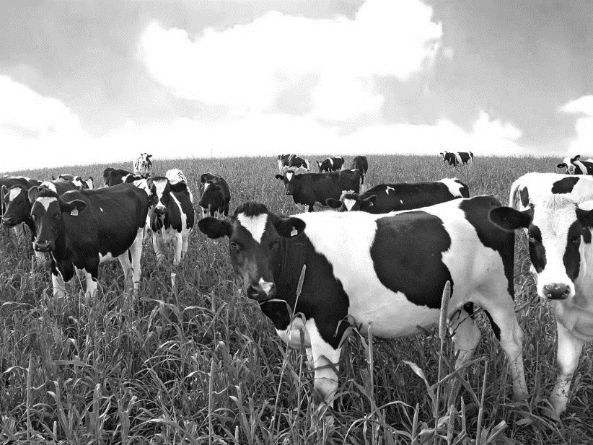

- Identify the above farming. (1)
- Where is such farming practised in Europe? Why is this farming practised in such areas? (2)
- How are the cooperatives proved to useful in such type of farming? (2)
- Name the products the following animals are farmed for: (2)
- Goat , ii) Pigs, iii) Poultry, iv) Reindeer.

