GREENLAWNS SCHOOL, WORLI
TERMINAL EXAMINATION-2019
SCIENCE
STD: VII TIME: 2hrs
Date: 20/09/2019 MARKS: 80
______________________________________________________________________
NOTE: Attempt all questions.
All diagrams to be done in pencil only.
All answers to be written on the answer booklet provided.
______________________________________________________________________
QI .Fill in the blanks: [6]
- _________________ is the greenpigment present in leaves.
- The _______________ is the main conduction unit of the neuron.
- The force of attraction between oppositely charged particles is called _________________ force.
- ____________ is a non-metal liquid at room temperature.
- ____________ is used as a bleaching agent.
- Melting and condensationare examples of ______________.
QII State whether the following statements are true or false. Correct the false statements: [6]
- Conduction of heat occurs in the liquid boiling in avessel.
- Evaporation takes place only at boiling point of a substance.
- The muscles control reflex actions.
- Plants do not have any specialized organ system for gaseous exchange.
- Mixtures are able to combine together to form compounds.
- Oxygen is used in cosmetic treatment.
QIIIA Name the following: [10]
- The property by which a metal can be drawn into wires without beating.
- A noble gas
- The formula of Sodium Chloride.
- An example of a gas-gas mixture.
- The tissue that conducts the glucose produced by the leaves to various parts of the plants.
- The waste product excreted by the skin.
- The freezing point of iron.
- The type of surface that is a poor reflector of radiation.
- Any two inflammable substances.
QIIIB Complete the following word equation: [3]
- Carbon dioxide +Water ---------------------- _______________ + _____________
- Glucose ----------------- _____________ + _____________ +Energy(2ATP)
- Iron +Air +Water vapour-------------------- __________________ or ___________.

QIVA Define the following terms: [5]
- .Galvanization d. Excretion
- Polyatomic ions e. Ignition temperature.
- Heterotrophic nutrition
QIVB Give two points of difference between the following with the help of the clues given within brackets: [10]
- Good conductors and Insulators (definition and example)
- Cerebrum and Cerebellum (location and function)
- Saprophytic nutrition and Symbioticnutrition(definition and example)
- Mixture and compound (characteristics)
- Diamond and Charcoal (physical property and use)
QV. Answer the following questions:
- What is suspension? [2]
- List any two ways to prevent rusting of iron. [2]
- What causes kidney stones? [2]
- Mention any two significance of photosynthesis. [2]
- Why cannot the sun’s heat reach us by conduction or convection? [2]
QVI. Give scientific reasons for the following:
- Clean snow does not melt rapidly. [2].
- When hot water is poured into a thick glass tumbler it cracks. [2]
- Copper is used for electrical wiring in our houses. [2]
- A fractionating column is used in fractional distillation. [2]
- Respiration is a process that releases energy. [2]
QVIIA Solve the following:
- Convert 81⁰ F into centigrade scale. [1½]
- Which of the two 10⁰C or 10ºF represents a high temperature? Justify [1½]

QVIIB Draw a neat labeled diagram showing the parts of a neuron: [2]

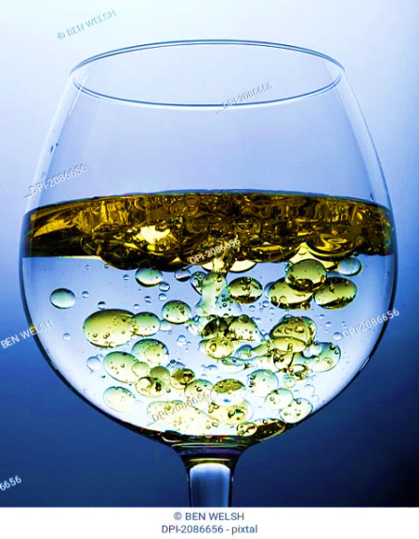
QVIIC Study the given diagram and answer the questions that follow:
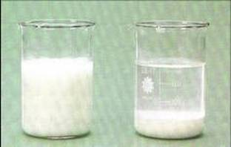
- Identify the mixtures you see in figure A and figure B [1]
- Give one example for each figure [2].
- Which method of separation would you use in figure A and figure B? [2]
QVIID With reference to the given diagram answer the questions that follow:
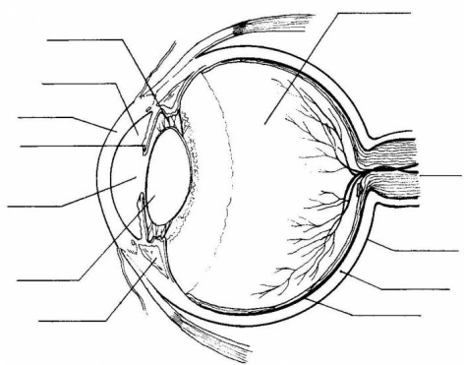
- Identify the parts 1 to 4. [2]
- Name the outer layer of the eye. [½]
- In which part of the eye is the image formed? [½]
- What covers the part 4? [½]
- Give any two ways to take care of our eyes. [1]
- How are our eyes protected? [1]
- Explain the function of the Pupil in the eye? [2]
- In which part of the eye are the rods and cones found? What is the function of these cells? [2½]

