GREENLAWNS SCHOOL, WORLI
FINAL EXAMINATION: 2019-20
SCIENCE
Std: V Marks: 80
Date: /02/2020 Time: 2 hrs
Carefully read this paper in the first ten minutes. Your answers should be concise and contain scientific terms. All answers have to be written on the answer script.

Q.1) Name the following: [5]
- The first step in the process of seed formation.
- The sound produced by sparrows.
- The disease caused due to mosquitoes.
- A fertilized cell
- Energy sources that last for a long period of time.

Q.2) Fill in the blanks: [5]
- Ferns reproduce through ___________
- Non-renewable energy sources cannot be easily made by natural means so we should use them ___________ and carefully.
- ___________ pollination is commonly seen in pea flowers.
- Unclean hair cause itching of the scalp and infections such as ___________
- ___________ sounds are loud to alert people about a danger or an emergency.

Q.3) State whether the following statements are true or false. If false, rewrite the correct [5]
statement by changing the underline word / words:
- Bisexual flowers are also called complete flowers.
- The pressure cooker makes a low hissing sound when steam escapes from it.
- We must clean homes regularly with cold water to kill germs.
- Hooks of the coconut palm stick to the bodies of animals and birds and are carried away to different places.
- Electrical energy is generated at power stations and supplied to our homes.

Q.4) Select the odd one out giving a reason for each: [5]
- Papaya, rose, watermelon, cucumber
- Pea, maple, balsam
- Swimming, running, playing, reading
- Diarrhoea, cholera, typhoid, jaundice
- Hydro, solar, petroleum, wind

Q.5) Define the following: [5]
- Noise d) Cross-pollination
- Vaccination e) Vegetative reproduction
- Work

Q.6) Give one point of difference between the following: [5]
- Use of wind energy and use of heat energy
- Potato and ginger
- Taking care of eyes and taking care of teeth
- Function of stigma and function of style
- Examples of sounds made by humans and animals

Q.7) Give reasons for the following:
- Animals and birds produce different sounds. [2]
- An ambulance siren makes a loud noise on its way. [2]
- Non-biodegradable waste must be dumped properly. [2]
- Work and energy are closely related to each other. [2]
- Seed dispersal is important for the proper growth and survival of the parent and [2] and new plants.

Q.8) Answer the following: [10]
- How do communicable diseases spread through food?
- Explain mechanical energy.
- How do animals help in seed dispersal?
- Mention the functions of sepal and petal.
- What is a pleasant sound? State examples of some pleasant sound.

Q.9) Answer the following diagram-based questions:
- The figure below represents the generalised arrangement of parts of a flower. Observe the figure and answer the questions that follow:
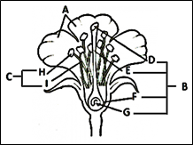
1) Name the parts A, B, C, D, E, F, H and I. [4]
2) What does H contain? [1]
3) What is thalamus? [1]
4) What do parts F and G become on fertilisation? [1]
5) Define pedicel. [1]

- The figure below represents an experiment to study the conditions necessary for the germination of seeds. Observe and answer the questions:
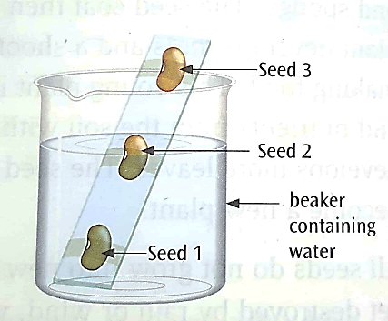
- What changes will you observe in the three bean seeds [3]
when the beaker is kept in a warm place for 2-3 days?
- Give valid reasons for your above answer. [3]
- What are the things essential for germination? [1]
- Define germination. [1]

- Carefully look at the picture given below on ways to manage non-biodegradable waste and explain them. [6]
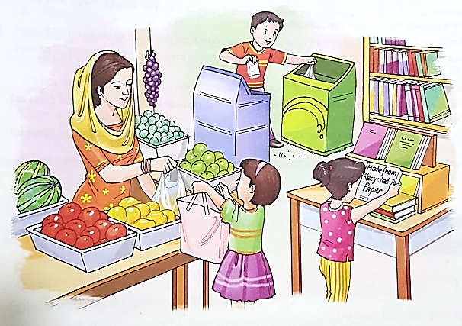

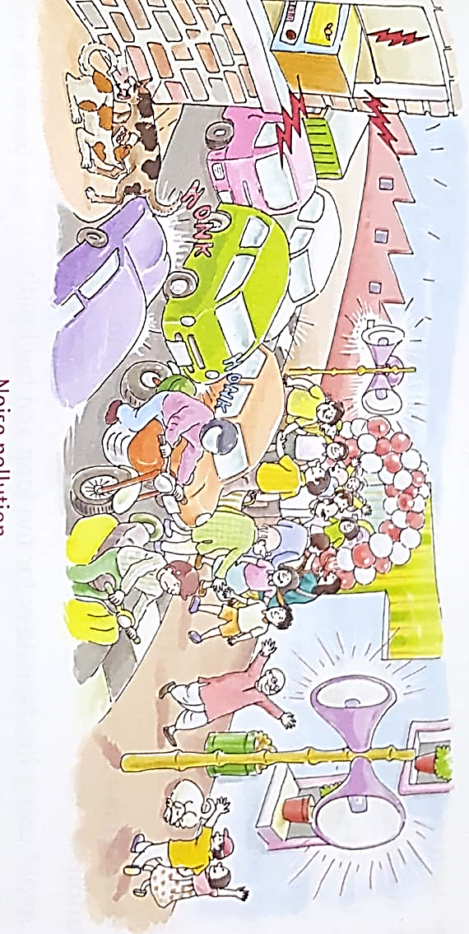

- Look at the picture given below and answer the questions:

- Define the pollution you notice in the picture. [1]
- What are the harmful effects of this type of pollution? [2]
- Suggest ways to reduce this type of pollution. [2]

Q.10) Draw a neat and labelled diagram of the stages of germination of a bean seed. [3]

******

