GREENLAWNS SCHOOL, WORLI
FINAL EXAMINATION: 2019-20
BIOLOGY
Std: VIII Marks: 80
Date: /02/2020 Time: 2 hrs
Answer to this paper must be written on the answer booklet provided to you. The first 10 minutes are to be spent in reading the Question paper. The time given at the head of this paper is the time allowed for writing the answers. All questions are compulsory.
Do not waste paper. Leave only one line after each answer.

I A) Name the following: [5]
- An artificial way of achieving protection from infections by introduction of dead or weakened germs into one’s body.
- Scientist who identified different types of blood groups in humans.
- The Greek word for house.
- The fertilized egg.
- Vaccine for poliomyelitis.

B) Fill in the blanks: [5]
- ___________ are those organisms which carry germs from a source of infection but themselves do not get the infection.
- The heart is made up of specialised muscles called ___________ muscles.
- ___________ means the plants naturally occurring in a particular area.
- ___________ is a mixture of sperms and secretions from seminal vesicles, prostate and Cowper’s glands.
- The idea of vaccination was conceived by ___________

C) Explain the following terms: [5]
- Implantation iv. Hypertension
- Vaccination v. Abiotic components
- Food chain

D) State whether the following statements are true or false. If false, rewrite the correct [5]
statement by changing the underline word / words:
- The uterus is a hollow, inverted pea - shaped muscular organ found in the pelvic cavity.
- Coniferous forests are found on the eastern coast of India.
- In case of a sting by a bee, we must apply some vaseline on that spot.
- Lymph contains special cells called lymphocytes that help to build immunity.
- Heterotrophs means differently nourished.

E) Give one main function of the following: [5]
- Valves iv. SA node
- First aid v. Oviducts
- Prostate gland
F) Give one difference between the following pairs on the basis of what is indicated in the
bracket. Answer only in tabular form. [5]
- Jaladpara sanctuary and Gir forests (fauna)
- Burns and bleeding (first aid)
- Arteries and veins (flow of blood)
- Malaria and Chikungunya (causative agent)
- Detritivores and scavengers (meaning)

G) Give scientific reasons for the following: [10]
- A food chain is in the shape of a pyramid.
- Blood flow through the heart is said to be double circulation.
- Food web provides more stability to an ecosystem than a food chain.
- A pair of testes lie outside the abdominal cavity in a sac called scrotum.
- Consumption of tobacco is considered to be harmful.

II A) Given below is the schematic diagram of the sectional view of the human male
reproductive system:
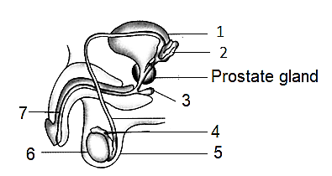

- Label the parts 1, 4, 5 and 7. [2]
- Give function of parts 2, 3 and 6. [3]
- Draw and label structure of human sperm. [2]

B) Give one example of a vaccine prepared by each of the following methods: [2]
- Using living weakened germs
- Using toxoids
- Using killed germs
- Using fully virulent germs
C) What is the exact location of the ovaries. [1]

III A) Observe the food web given below and answer the questions that follow:
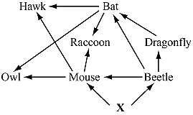
i. Identify and describe the ecological role of [2]
organism X in the food web.
ii. Identify two organisms in the food web whose [1]
population size would increase if the bat became
extinct.
iii. Define food web. [1]

B) State the symptoms of Measles. [2]
C) ‘Many viral and bacterial diseases of the respiratory tract are transmitted through droplets.’
Describe any one such disease that spreads through droplet infection. [2]
D) Write short note on Dengue. [2]

III A) ‘Interdependence between organisms arise from the interaction of populations of two [6]
different species. These interactions could be beneficial, harmful or neutral to one species
or both.’ Explain three such relationships among the organisms.
B) Give the full form of AIDS and HIV. [2]
C) What is ‘Heart Attack’? Mention some of its common symptoms. [2]

V A) The figure below represents internal structure of the human heart.
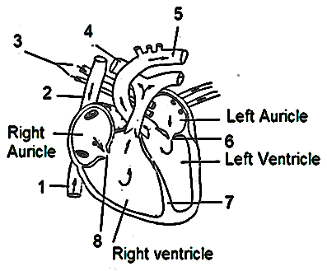

i. Label parts 1, 2, 5 and 7. [2]
ii. Name the valves 6 and 8. [1]
iii. Distinguish between 3 and 4. [1]
iv. How is the heart protected? [2]
v. Why are the ventricles large with thick and [1]
muscular walls?

B) Describe Binary fission in amoeba. Support your answer with a diagram. [3]

******

