GREENLAWNS HIGH SCHOOL
PHYSICS TERMINAL EXAMINATION 2023-24
STD. 10 TIME: 2 HRS.
DATE: 9/10/2023 MARKS: 80
NOTE:
1] Answer to this paper must be written on the paper provided separately.
2] You will not be allowed to write during the first 10 minutes. This
time is to be spent in reading the paper.
3] The time given at the head of this paper is the time allowed for
writing the answers. This paper has 4 pages (7 sides)
4] Section A is compulsory. Attempt any 4 complete questions from
Section B.
5] The intended marks for a question or parts of questions are given in the brackets [ ].

SECTION A [40 MARKS]
ALL QUESTIONS IN THIS SECTION ARE COMPULSORY.

QUESTION 1
A] Choose the most correct answers to the questions from the given options:[15

(i) In the white light of sun, maximum scattering by the air molecules present in the earth’s atmosphere is for:
a) red colour b) yellow colour c) green colour d) blue colour

(ii) Two sounds A and B which are of the same amplitudes and the same wave forms have frequencies f and 2f respectively then
a) B differ in quality from A. b) B is flat, A is shrill.
c) B is shrill, A is flat. d) B is louder than A.

iii) Observe the given figure and calculate the refractive index of medium B with respect to medium A.

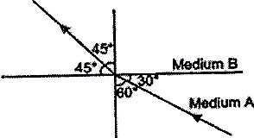 a) b) c) d)
Page 2

iv) The work done on a body depends on the
a) distance moved by the body b) mass of the body
c) acceleration due to gravity d) all of these

v) The radiations used in satellite communication are
a) Ultraviolet radiations b) Infrared radiations c) Microwaves
d) Visible light

vi) A simple pendulum oscillating in air with a certain frequency ceases to oscillate after some time. The vibrations executed are
a) forced vibrations b) free vibrations c) damped vibrations
d) resonant vibrations

vii) For which of the following substance, resistance decreases with increase in temperature.
a) Copper b) Mercury c) Carbon d) Platinum

viii) The mechanical advantage of a combination of single fixed pulley and a single movable pulley in an actual situation is
a) 1 b) less than 1 c) 2 d) less than 2

ix) The centrifugal force is
a) a real force b) the force of reaction of centripetal force
c) a fictious force d) directed towards the centre of a circular path

x) Two unequal resistances are connected in parallel across a cell. Which of the following statements is true?
a) Current flowing through smaller resistance is higher
b) Current flowing through larger resistance is higher
c) Current flowing through both the resistances is equal
d) Current can be higher in any resistance depending on the emf of the cell

xi) The class II levers are designated to have
a) M.A. = V.R. b) M.A. V.R. c) M.A. 1 d) M.A. 1

xii) Which of the following quantity remains constant in a uniform circular motion.
a) Velocity b) Speed c) Acceleration d) Both velocity & speed

Contd………..

Page 3

xiii) In parallel combination of resistances
a) potential difference is same across each resistance
b) total resistance is increased
c) current is same in each resistance
d) all above are true

xiv) In case of refraction through a prism, which one is the correct relation between the different angles?
a) i + δ = A + e b) i + A = e + δ
c) i + e = A + δ d) i = A + e + δ

xv) An object in a denser medium when viewed from a rarer medium appears to be raised. The shift is maximum for
a) red light b) green light c) violet light d) yellow light

QUESTION 2

A] i) Draw a V-I graph for a conductor obeying Ohm’s law. [2]
ii) What does the slope of I- V graph for a conductor represent?

B] At which point the centre of gravity situated in a [2]
i) triangular lamina ii) hollow cylinder

C] i) Name the phenomenon involved in tuning a radio set to a particular [2] station.
ii) Which type of vibrations are involved in the phenomenon mentioned by you in Q.2 – C – i

D] State the energy changes in the following cases while in use: [2]
i) a petrol engine in a car ii) Solar cell

E] i) Name the region that lies between the ultraviolet and infrared regions. [2]
ii) Write one use of the radiations that occur in the region mentioned by you in Q.2-E-i

F] What type of a lever is formed by the human body while [2]
i) raising a load on the palm ii) raising the weight of body on toes?

Contd…………
Page 4

G] Draw a neat labelled diagram showing the image formation by a converging lens for an object which is kept very far away from it. (u f) [3]

QUESTION 3

A] The graph given below shows the changes in kinetic energy and potential energy with the height above the ground. Observe the graph and state with reason which graph will indicate the change in kinetic energy? [2]

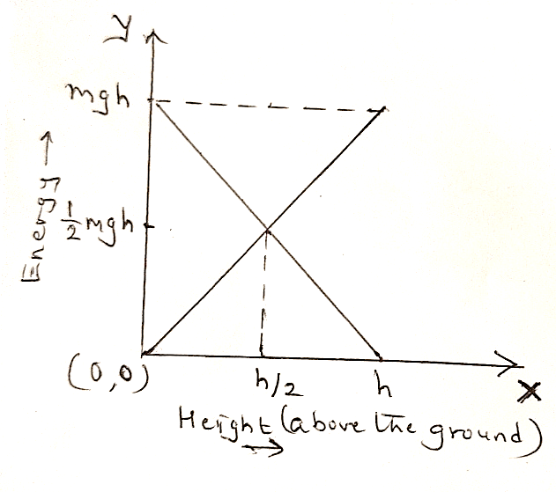

B] Name the unit in which the energy of an atomic particle is measured. Write its relation with the SI unit of energy. [2]

C] State two conditions necessary for the total internal reflection to occur. [2]

D] State two conditions when the work done is said to be zero. [2]

E] How do the following factors affect the resistance of a conductor? [2]
i) length of a conductor ii) thickness of a conductor

Contd……

Page 5

SECTION B (40 MARKS)
ATTEMPT ANY 4 COMPLETE QUESTIONS FROM THIS SECTION

QUESTION 4
A] A girl stands 60m in front of a tall wall and claps. The girl continues to clap and every time an echo is heard. Another girl finds that the time taken between the first and fifty-first clap is 18 s. Calculate the speed of sound. [3]

B] Define: [3]
i) Critical angle ii) SI unit of potential difference iii) Echo

C] Name the following: [4]
i) The work done in carrying a unit charge through the electrolyte.
ii) The point on the principal axis of the lens such that a ray of light passing through this point emerges parallel to its direction of incidence.
iii) The product of efficiency and velocity ratio of the machine.
iv) The energy possessed by an object by the virtue of its configuration.

QUESTION 5
A] Observe the diagram given below and answer the questions that follow: [3]
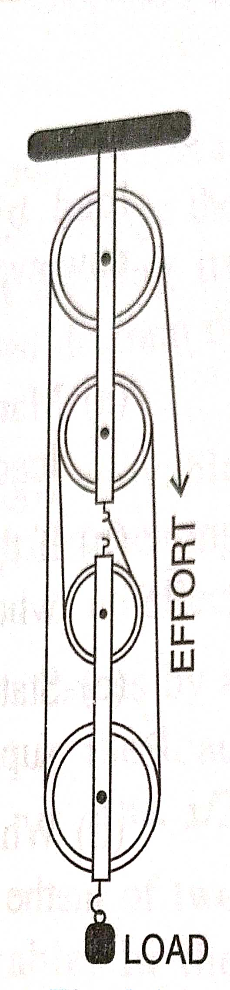

i) Calculate the mechanical advantage of the block and tackle system shown above under ideal conditions.
ii) Draw a neat labelled diagram to get the mechanical advantage greater than obtained by you in Q.5 A-i , by using the same number of pulleys.
Page 6

B] Write the subjective property associated with each of the following: [3]
i) Frequency ii) Intensity iii) Wave form

C] Answer the following questions with respect to the radiations having wavelength 10 nm to 400 nm. [4]
i) Source ii) method of detection iii) one property iv) one use

QUESTION 6
A] Two isosceles right angled prisms P & Q are placed near each other as shown in the figure given below. Copy the diagram in your answer booklet and complete the path of the light ray entering the first prism P till it emerges out of the prism Q. Show all the necessary angles. [3]
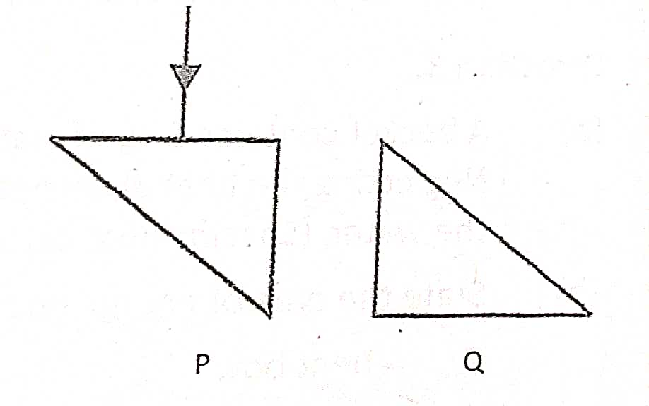
B] i) Define refraction of light. [3]
ii) State the laws of refraction.

C] A horse exerts a pull on a cart of 300 N so that the cart moves with a uniform speed of 18 kmh⁻¹ on a level road. [4]
i) Calculate the power developed by the horse in SI unit.
ii) Find its equivalent in horse power.

QUESTION 7

A] State the law/principle applicable in each of the following cases: [3]
i) K + U = Constant (when there is no frictional force or dissipation)
ii) W = ½ mv² – ½ mu²
iii) Load x Load arm = Effort x Effort arm (in equilibrium)

Contd…….

Page 7
B] Give scientific reasons of the following: [3]
i) A rock-salt prism is used to study the infrared radiations.
ii) A sugarcane grinder has a long handle.
iii) While verifying Ohm’s law, the temperature of a conductor has to be constant.

C] A given wire of resistance 2.5Ω is stretched to double its length. What will be its new resistance? [4]

QUESTION 8

A] Draw a neat labelled diagram using a right-angled isosceles prism to turn a small ray AB (object) through 180⁰. Name a device in which this action of prism is used. [3]

B] The focal length of a camera lens is 20 cm. Find how far away from the film must the lens be set in order to photograph an object located at a distance of
60 cm from the lens. Also write the position of the object. [3]

C] Differentiate between the following pairs on the basis of what is given in the brackets. [4]

i) Dynamic equilibrium & Static equilibrium (meaning)
ii) Natural vibrations & Damped vibrations (forces involved)
iii) Total internal reflection & Reflection from a plane mirror (angle of incidence)
iv) 2nd order lever & 3rd order lever (position of the load, fulcrum & effort)

QUESTION 9
A] State the principle of an ideal machine. [3]
Why it is not possible to have an ideal machine in reality? (Give 2 points)

B] State three conditions required for an echo to be heard. [3]

C] Three resistors of 6 Ω, 3 Ω and 2 Ω are connected together so that the total resistance is greater than 6 Ω but less than 8 Ω. Draw a diagram to show this arrangement and calculate the total resistance. [4]

