GREENLAWNS HIGH SCHOOL
FINAL EXAMINATION 2022 – 2023
SUBJECT: ENGLISH I MARKS: 80
CLASS: V TIME: 1 ½ HOURS
SECTION I
QUESTION I: Composition [20]
Write an original Composition of about 200 words on any one of the given topics. {You must use at least seven words from the word bank given}
1: My Plane Travel
[Word bank: reason- book tickets- packing- reaching the airport- airport formalities: check-in and security- boarding-flight experience- landing- arrival and reaching the destination.]
[OR]
2: Study the given set of pictures carefully and write a Composition on it:
[Word bank: Fortunate enough to have grandparents- advice and assistance-symbol of wisdom-play with grandchildren-inculcate values and traditions- story telling-traditional food and culture- homemade medicines- any incident-learn new technology- complete family with them.]
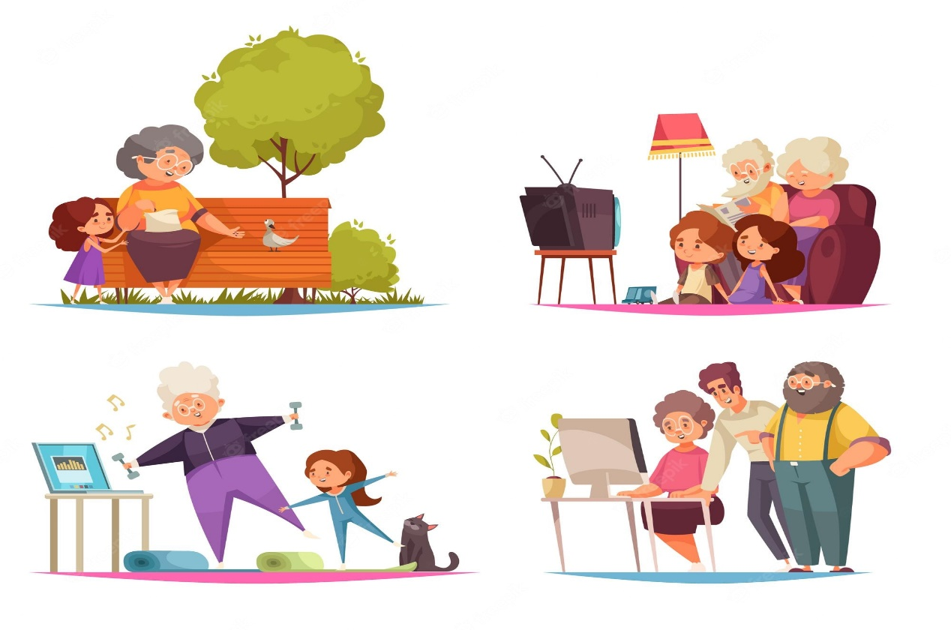

Question II: Letter Writing [10]
Write a letter to your mother explaining the reason for your poor performance in your exams and your plan for improving in the Final examination.
Question III: Comprehension [20]
Read the passage given below carefully and answer the questions that follow:
There were only a handful of families which educated their daughters so that they can also live the life they deserve. These women who got the freedom to education from their families, turned out to be the path setters for other women to follow. They were the ones who became an inspiration for other women and motivated them to follow their ambitions as well. They brought about a change for the betterment of the status of women in Indian Society.
Women possess incomparable qualities like a calm mind, the strength to overcome any emotional challenge, and handle the toughest situation with ease and optimism. Women keep their families intact and act as the thread which joins all the differences and people together. They are worshiped as goddesses in the name of Durga, Parvati, Kali, and Saraswati. As times changed, the status of women too changed and reached higher standards.
All the world knows our golden girl, sprint queen P.T. Usha. She bagged several golds in international athletic meets. She revealed that nothing is impossible for Indian women. Vijayalakshami Pandit caught the world’s attention by becoming the first woman President of the U.N. General Assembly. Sarojini Naidu, the Nightingale of India, was a popular freedom fighter. C.B. Muthamma became the first Indian woman ambassador. She was the Indian diplomat in Hungary. Shakuntala Devi of Karnataka proved the intellectual capacity of the Indian woman. The songs of M.S. Shubhalakshami and the poetical works of Amrita Pritam are well known all over the world. Santosh Yadav in mountaineering and Kalpana Chawla,the brave astronaut who met her tragic end while in space, have captured the hearts of millions through their astonishingly brave deeds. The day is not far away when India will produce a Madam Curie or a Pearl S. Buck.
Answer the given questions:
1) How did the women who got the freedom to education turn out? (1)
2) What are the quantities that women possess? (2)
3) List the names of female goddesses. (2)
4) Why is P.T. Usha called the ‘golden girl’? (1)
5) How did Vijayalakshmi Pandit catch the world’s attention? (1)
6) Why do we take the names of Shakuntala Devi, M.S. Subhalakshami and Amrita Pritam with pride? (2)
7) How has Kalapana Chawla captured the hearts of millions? (2)
8) Give a suitable title for the passage above. (1)
9) Which woman inspires you and Why? (2)
10) Find the words from the passage which mean the same as: (3)
a) make known to others –
b) to catch someone –
c) skills or special abilities –

11) Make sentences with the words given below: (3)
a) attention –
b) popular –
c) motivate -
Question IV: Grammar [30]
A Complete the sentences with the correct Coordinating Conjunctions: [3]
- She does not like apples, does she like oranges.
- He has a small house, it feels very spacious.
- I have a pencil, it is not sharpened.
- I will be late for the party, I will be having dinner with my parents first.
- I will read a book I will just watch TV.
- Sameer drank some water he was thirsty.
B Complete the sentences with the correct Correlating Conjunctions: [3]
- I go for a walk spend time with my father chatting.
- My sister likes to play the piano the guitar.
- Alex shows up not, we will leave for the airport at 6 a.m. tomorrow.
C Select the correction preposition to complete the sentences: [3]
- I was born 2011. [on/in/at]
- Let us have fun Thanksgiving. [on/in/at]
- The cab will be here an hour. [on/in/at]
- Priya wakes up 7 ‘o’clock in the morning. [on/in/at]
- They work together Sunday afternoons. [on/in/at]
- The Second World War was fought the 20th century. [on/in/at]
D Choose the right preposition for framing the questions: [3]
- Do you ever get up sunrise? [on/in/at]
- what time do you go to school? [on/in/at]
- What time do you usually do the weekends? [on/in/at]
- Were you born the 1990s? [on/in/at]
- Do you remember what did you do Tuesday afternoon? [on/in/at]
- Do you take a nap the afternoon? [on/in/at]
E Match each Subject with the correct predicate: [6]
(only write the correct alphabet against the number for e.g. 7-g)
- The boy | - are very good friends.
- The grandfather | - is my favourite.
- Orange, white and green | - flowers bloom.
- May, Todd and Koko | - smiled when he held the baby.
- The peacock cake | e. are the colours of the flag.
- In the spring | f. is in first grade.

F. Choose the right form of verb from the given options: [6]
1. Neither of the printers properly. [work/works]
2. One of the diamonds stolen. [was/were]
3. Bread and butter my favourite breakfast. [is/are]
4. Nine and nine eighteen. [makes/make]
5. What a pair of jeans cost? [do/does]
6. None of these flowers well inside the house. [grows/grow]
G. Identify the type of sentence given below: [6]
- I am sick and tired of chasing that dog out of my yard.
- Are you sure you want to sign up for that class?
- Quickly move those tables before they show up!
- School begins promptly at 8:05 am.
- Get up right now and rush to the bathroom.
- Be quiet.

------------------------------------------THE END --------------------------------------------

