GREENLAWNS SCHOOL, WORLI
TERMINAL EXAMINATION-2019
MATHEMATICS
STD: X MARKS: 80
DATE: 20/ 09 /19 TIME: 2½ hrs

Section I
(Attempt all questions of this section)

Question 1

(a) Given A = $\left[\begin{matrix}2 & -4 \\ 0 & 1\end{matrix}\right]$, B = $\left[\begin{matrix}4 & 6 \\ -3 & 1\end{matrix}\right]$ and A² – 2B + 3I = C, find matrix C. If I is an [3]
Identity matrix.
(b) A man deposits `500 every month in a recurring deposit account and receives `16,550 [3]
at the end of 2½ years. Calculate the rate of interest given by the bank.
(c) All black kings and black queens are removed from a pack of cards. If a card is drawn [4]
out at random, find the probability of obtaining a
(i) face card (ii) king or a queen (iii) king or a red card.

Question 2

(a) Use Remainder theorem to factorize the following polynomial: [3]
2x³ + 3x² – 9x – 10

(b) The sum of the first 15 terms in an AP is 0. If the fourth terms is 12 find the 12th term. [3]

(c) In the given figure, PT is a tangent and PAB [4]
is a secant to the circle. If $∠$PTA = 35⁰ and
$∠$ATB = 50º, TM is the bisector of $∠$ATB.
(i) Find measures of $∠$TMP
(ii) Prove that PT = PM,
(iii) Find BP if PT = 6 cm and AP = 3 cm.

Question 3

(a) If (x² – x – 2) is a factor of x³ + (a + 1) x² – (b – 2) x -6, find ‘a’ and ‘b’. [3]
(b) Prove that: $\frac{\tan^{3}θ}{{1+ tan}^{2}θ}$ + $\frac{\cot^{3}θ}{{1+ cot}^{2}θ}$ = sec$θ$ . cosec$θ$- 2sin$θ.cosθ$ [3]

(c) Solve for x, for the given AP, if (1 + 4 + 7 + ….. + x) = 247. [4]

Question 4

(a) Solve the following inequation and represent the solution set on the number line. [3]
-2 $≤ \frac{2}{3}$- $\frac{x}{2} ≤ 1\frac{1}{6}$, x$∈$ N.
(b) In the given figure, [3]
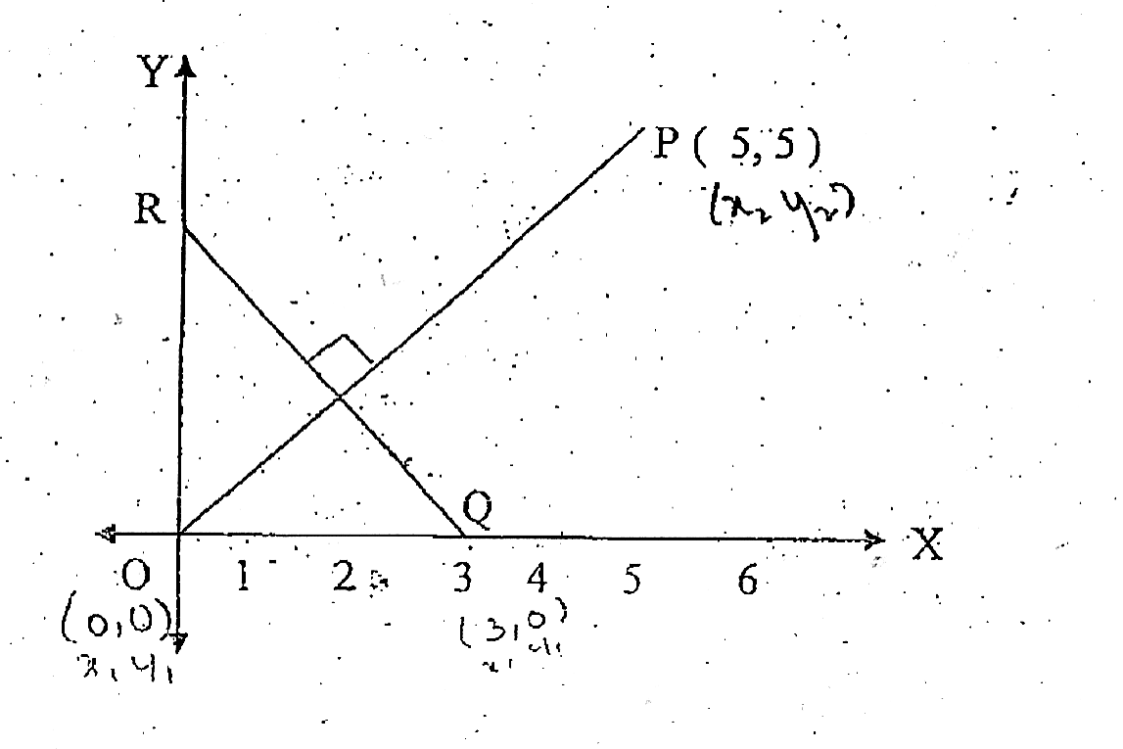
(i) Write the slope of OP,
(ii) Find the equation of QR, which is
perpendicular to OP.
(iii) Hence, write the co-ordinates of R.

(c) Solve and give answer correct to 3 significant figures. [4]
(x – 4)² - 5x - 3 = O.

SECTION – B
(Attempt any four question of this section)
Question 5

(a) The second term of a GP is $\frac{9}{4}$ and the eighth terms $\frac{16}{81}$. Find the GP. [3]

(b) In the circle with centre O, chords AB and CD intersect externally of P and PT is a [3] tangent to the circle at T. If PB = 12 cm, AB = 15 cm and DP = 6 cm find the length
of PT and the radius.

(c) Points (4, 0) and (-3, 0) are invariant points under reflection in the line l₁. Points (0, -2), [4] and (0, 3) are invariant points on reflection in l₂.
(i) Name the lines l₁ and l₂
(ii) Write down the images of point P(1,4) and Q(-3,5) on reflection t₁.
Name the images as P’ and Q’ respectively.
(iii) Write down the images of P and Q on reflection in l₂ . Name the images as P” and Q” respectively.
(iv) State or describe a single transformation that maps P’ onto P”

Question 6
(a) If x =$\frac{\sqrt{a+1}+ \sqrt{a-1}}{\sqrt{a+1}- \sqrt{a-1}}$using the properties of proportion show that x² – 2ax + 1 = 0 [3]
(b) Given: $\left[\begin{matrix} 2 & 1 \\ -3 & 4\end{matrix}\right]$.X =$\left[\begin{aligned}7 \\ 6\end{aligned}\right]$ [3]
Write (i) the order of the matrix X (ii) the matrix X
(c) Prove the given identity: cot²A $\left(\frac{\sec{A-1}}{1+\sin{A}}\right)$+ sec²A$\left(\frac{\sin{A-1}}{1+\sec{A}}\right)$ = 0 [4]

Question 7

(a) Find the value of k so that the equation (k + 4)x² + (k + 1)x + 1 = 0 has real and [3]
equal roots.

(b) A man has a recurring deposit account in a bank for 3 years at 8% p.a. If he gets `399 [3] as interest at the time of maturity of the scheme, find.
(i) the monthly installment. (ii) the maturity amount.

(c) Find the equation of a line through P(5, -2) and perpendicular to the line 2x – 7y = 1. [4]
If (k, k + 2) lies on that line, find the value of k.

Question 8

(a) A plane left 30 minutes later than the scheduled time and in order to reach its destination[3] 1500 km away in time, it has to increase its speed by 250 km/hr from its usual speed.
Find its usual speed.

(b) Find the value of p if the mean of the following distribution is 18. [3]

x | 13 | 15 | 17 | 19 | 20 + p | 23
f | 8 | 2 | 3 | 4 | 5p | 6

(c) Construct a regular hexagon of side 4.5 cm. Inscribe a circle in it. [4]

Question 9

(a) An aeroplane, when 300 m high passes vertically above another aeroplane at an instant [4]
when the angles of elevation of the two aeroplanes from the same point on the ground
are 60º and 45º, respectively. Find the vertical distance between the two aeroplanes to the nearest meter.

(b) Use graph paper for this question. [6]
[Scale: 2 cm = 10 units on both axes]
Draw an ogive from the following frequency distribution.

Marks | No. of students
0 - 10 | 5
10 - 20 | 9
20 - 30 | 16
30 - 40 | 22
40 - 50 | 26
50 - 60 | 18
60 - 70 | 11
70 - 80 | 6
80- 90 | 4
90 - 100 | 3

Use the given data and ogive to estimate
(i) The median class,
(ii) The median marks,
(iii) The number of students who scored more than 75 marks,
(iv) The number of students who scored 40 or more than 40 but less than 60 marks.

*****************

