GREENLAWNS SCHOOL, WORLI
TERMINAL EXAMINATION: 2019-20
BIOLOGY
Std: IX Marks: 80
Date: 30/09/2019 Time: 2 hrs
Answer to this paper must be written on the answer booklet provided to you.
The first 10 minutes are to be spent in reading the Question paper. The time given at the head of this paper is the time allowed for writing the answers. All questions are compulsory.
Do not waste paper. Leave only one line after each answer.

I A) Name the following: [5]
- Deficiency disease in children caused by lack of iodine in diet.
- Condition when perianth is non-green.
- The process of formation of a seedling developed from the embryo.
- Condition in which there is complete loss of pigmentation of the skin.
- Kingdom that includes unicellular and prokaryotic organisms.

B) Match the organisms with their scientific names: [5]
- Housefly a. Solanum tuberosum
- China rose b. Canis familiaris
- Dog c. Musca domestica
- Potato d. Ananas comosus
- Pineapple e. Hibiscus rosa-sinensis
f. Hibiscus esculentus

C) Fill in the blanks: [5]
- Certain fishes such as __________ devour mosquito larvae.
- Vacuoles in plant cells contain a liquid called __________
- __________ is the disposal of waste by burning.
- Disaccharides have a general chemical formula __________
- The tip of the flower stalk may be expanded to form a __________

D) State whether the following statements are true or false. If false, rewrite the correct [5]
statement:
- Albuminous cotyledons are thick and fleshy.
- Hookworms belong to phylum annelida.
- Meibomian glands are modified sebaceous glands which open of margins of eyelids.
- Red Cross is a specialised agency of the United Nations Organisation.
- Fused sepals are said to be gamosepalous.

E) Explain the following terms: [5]
- Placentation iv. Hypogeal germination
- Eukaryotic cell v. Composting
- Species

F) Differentiate on the basis of what is indicated in brackets: [5]
- Stratum corneum and stratum Malpighi (function)
- Cholera and amoebic dysentery (causative agent)
- Vertebrates and invertebrates (location of heart)
- Chloroplast and chromoplast (pigment present)
- Monoecious and dioecious plants (meaning)

G) Give one reason in support of each of the following facts: [5]
- The skin pigment acts like an “umbrella”.
- Housefly is often designated as Public Enemy No. 1.
- Cellulose is important for our diet.
- The earthworm is highly useful in agriculture.
- Seeds sown very deep in soil fail to germinate.

H) Give two examples of each of the following: [5]
- Plants that grow by epigeal germination
- Animals of phylum Echinodermata
- Unisexual flowers
- Diseases spread by mosquito
- Methods of safe disposal of waste

II A) The figure below shows an animal.
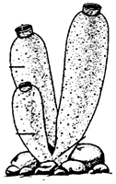

- Identify the animal. [½]
- To which phylum does it belong? [½]
- Give two identifying features of this phylum. [2]
- What is binomial nomenclature? [1]
- What are the two main rules of writing scientific names? [2]

B) Mention any two main activities of WHO. [2]
C) Give functions of the following nutrients: [2]
- Vitamin K ii. Iron

III A) Draw a neat diagram of an animal cell and label the following parts: [3]
- Supportive framework for the cell
- Regulates the entry of certain solutes and ions
- Protein synthesis
- Initiates and regulates cell division
- Gives turgidity to the cells
- Synthesis and secretion of hormones

B) The following figure represents the cross-section of a whorl of a flower.
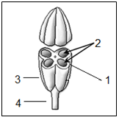
- Label the parts 1 to 4. [2]
- How are contents of part 1 usually ejected? [1]
- What is the collective name for the organs of this kind? [1]
- In part 2 are the contents male or female? [1]

C) What functions do the following structures perform? [2]
- Erector muscle of hair ii. Sebaceous gland

IV A) The figure below represents condition of the blood vessels in hot and cold weather.
Observe the figures and answer the questions that follow:
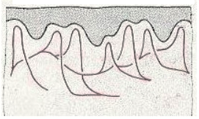
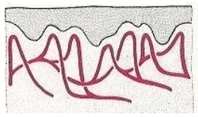

A B

- Identify the two conditions depicted in the figures above. [1]
- How is the body temperature regulated by the conditions mentioned by you above? [4]
- What is heatstroke? [1]

B) Write a short note on Electrostatic precipitators. [2]

C) What is Kwashiorkor? Mention any two of its symptoms. [2]

V A) The figure below represents a set-up to study an experiment on germination. Observe and
answer the questions that follow:
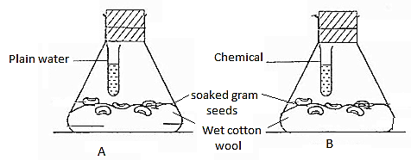

- What is the aim of this experiment? [1]
- Name the chemical in set-up ‘B’ and its role in this experiment. [1]
- What will you observe after some time in both the set-ups? [1]
- What is viviparous germination? [1]
B) State any four features of Class Reptilia. [2]
C) Suggest any two methods to control houseflies. [2]
D) Answer the following questions with respect to the Bean seed: [2]
- Function of Testa
- Meaning of Hilum

******

