GREENLAWNS SCHOOL, WORLI
FINAL EXAMINATION – 2020
GEOGRAPHY
Std: VI Marks: 80
Date: 11/02/2020 Time: 2 Hrs
NOTE: 1. Read all questions carefully.
2. Answer all Questions.
3. Do not copy any question in your answer booklet. Write answers only.
4. The maps must be attached behind your answer booklet.

SECTION A – MAP WORK (10 marks)

Q I] On an outline maps of the South America, label and colour the following.
(The key must not be reflected on your map.) (10)

- The ocean to the east of South America
- The grasslands of Argentina
- The country of Bolivia
- The sea to the north of South America
- The Equator
- The continuation of the Western Cordilleras in South America
- The Patagonian Desert
- The Amazon River
- The Brazilian Highlands
10) The largest country in South America

SECTION B – 21 marks

Q II] Fill in the blanks. (5)

- __________ __________ has been the gateway to Argentina for centuries.
- The process of separating minerals from their ores, by heating beyond a melting
point, is known as ________________.
- The largest organisation fighting for the indigenous people in Amazonia is
_______________.
- Shifting agriculture is also called ____________ and burn agriculture.
- There are more than 1,500 species of colourful birds in South America and it is
also known as the ______________ Continent.

Q III] State whether the following statements are true or false. Correct the false
statement and rewrite the answer in a complete sentence. (5)

- Pearl fishery is fishing of mackerel and lobsters.
- The La Plata River Basin is a wild fertile basin located to the south of the Amazon
Basin.
- The tea plant requires heavy rainfall during the winter season.
- The seasons in the Northern Hemisphere are the same as those in the Southern
Hemisphere.
- Bauxite is the ore from which aluminium is extracted.

Q IV] Answer the following in a word or two. (6)

- The grasslands of Russia where wheat is grown. –
- The strait that separates South America from the island of the Tierra del Fuego. –
- The biggest tree of the Amazon rainforest. –
- The wettest place in Colombia. –
- The gold mines in Karnataka. –
- The product obtained from the red quebracho tree in The Gran Chaco region. –

Q V] Match the minerals in column ‘A’ with their uses in column ‘B’. (Copy column
‘A’ and write the answers in column ‘B’) (3)

‘A’ ‘B’
1) Petroleum a) making bridges
2) Gold b) making aeroplanes
3) Copper c) chemical industry
4) Iron ore d) as flooring
5) Bauxite e) as fuel
6) Coal f) making wires
g) making jewellery

Q VI] With reference to the picture given below, answer the following questions (2)

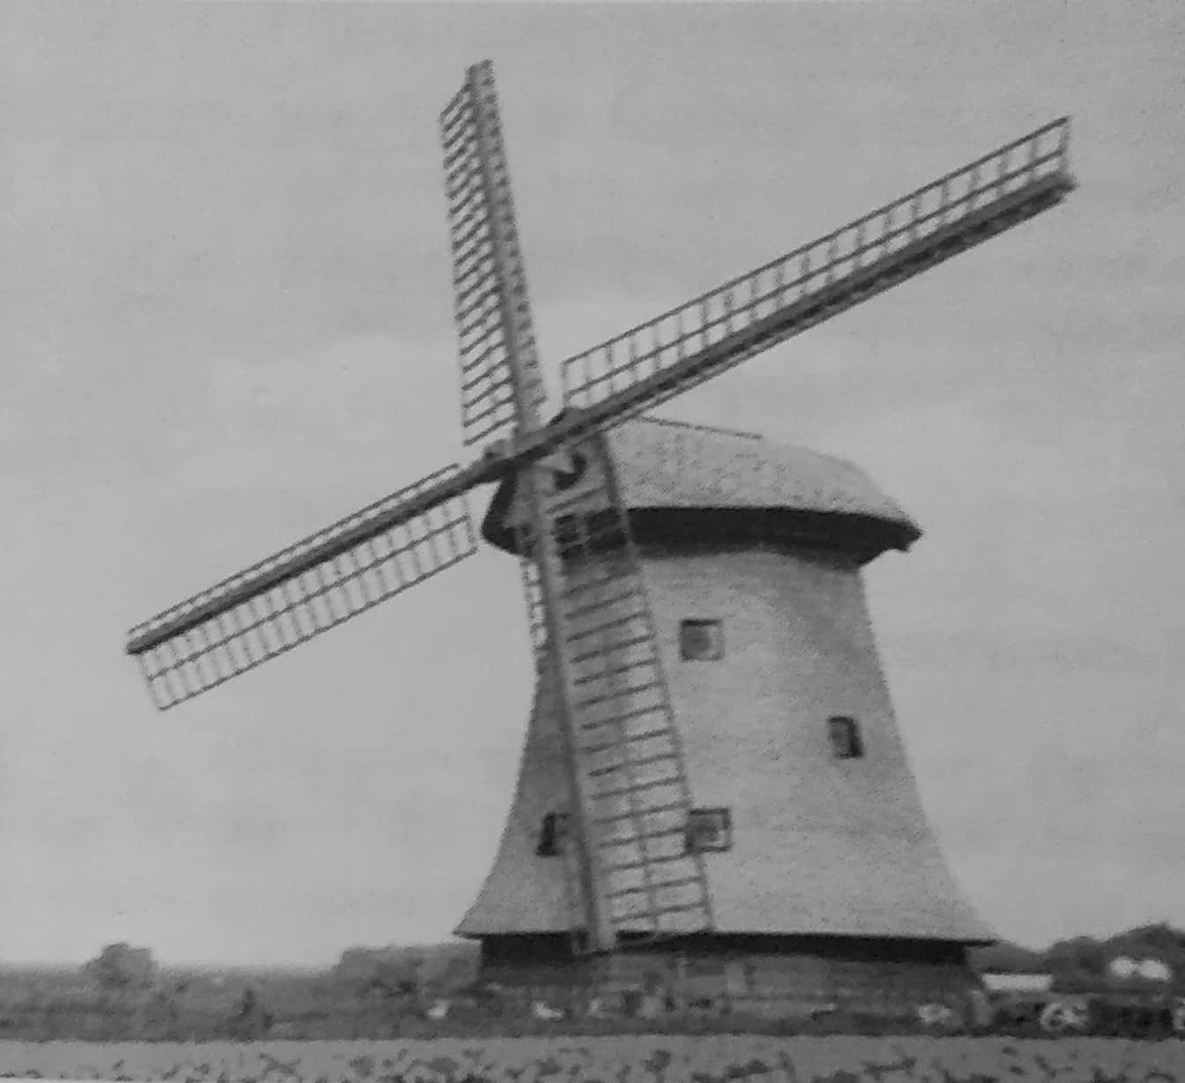

- Identify the structure in the above picture. Name the Indian state that uses a
similar structure to obtain wind energy. (1)
- Highlight two drawbacks of wind energy. (1)

SECTION C- 49 marks

Q VII] With reference to the Minerals found in South America, answer the following
questions: (4)

- Name the country that is the leading producer of copper. (1)
- Name the country that is the leading producer of tin. (1)
- Highlight the use of nitrates that are found in Chile. (1)
- Name the country that has rich reserves of mineral oil. (1)

Q VIII A] Explain the following terms: (4)

- Amazonia
- Livestock
- Fazendas
- Photovoltaic Cell

Q VIII B] Answer the following questions in one sentence only: (6)

- Name the two currents that greatly influence the climate of the coastal areas in
South America.
- List two supplementary sources of obtaining food for the people of Amazonia.
- In what form are metallic minerals found? Which rocks contribute to the
development of such minerals?
- How is transport made available from North to South in the Amazon Basin?
- Name the desert that is found in the Andes Mountains. Highlight the feature of
this desert.
- What kind of soil is suitable for the growth of the jute plant?

Q VIII C] Distinguish between the following terms, with respect to the points given in
brackets. (6)

- Central Plains and Eastern Highlands (Location and Waterbodies in the regions) (2)
- Lignite and Bituminous (Colour and Carbon content) (2)
- Equatorial Climate and Tropical Climate (Location and South American countries
with such climates) (2)

Q IX] Answer the following questions: (11)

- In what way do the Andes Mountains connect South America to the continent
of Antarctica? (2)
- Highlight the features of iron ore that help to make it easily adaptable? (3)
- What are the benefits of consuming the Yerba mate plant? (2)
- Explain the concept of ‘subsistence agriculture’. (2)
- What is unique about many peaks in the Andes Mountains? (2)

Q X] Give geographical reasons for the following: (6)

- Lake Maracaibo is a bay rather than a lake. (1)
- Pampas is called the ‘Granary of South America’. (1)
- South America has a large variety of climate and vegetation types. (2)
- The Selvas of the Amazon Basin are called the ‘lungs of the world’. (2)

Q XI] Picture Study
A] With reference to the picture given below, answer the following questions. (6)

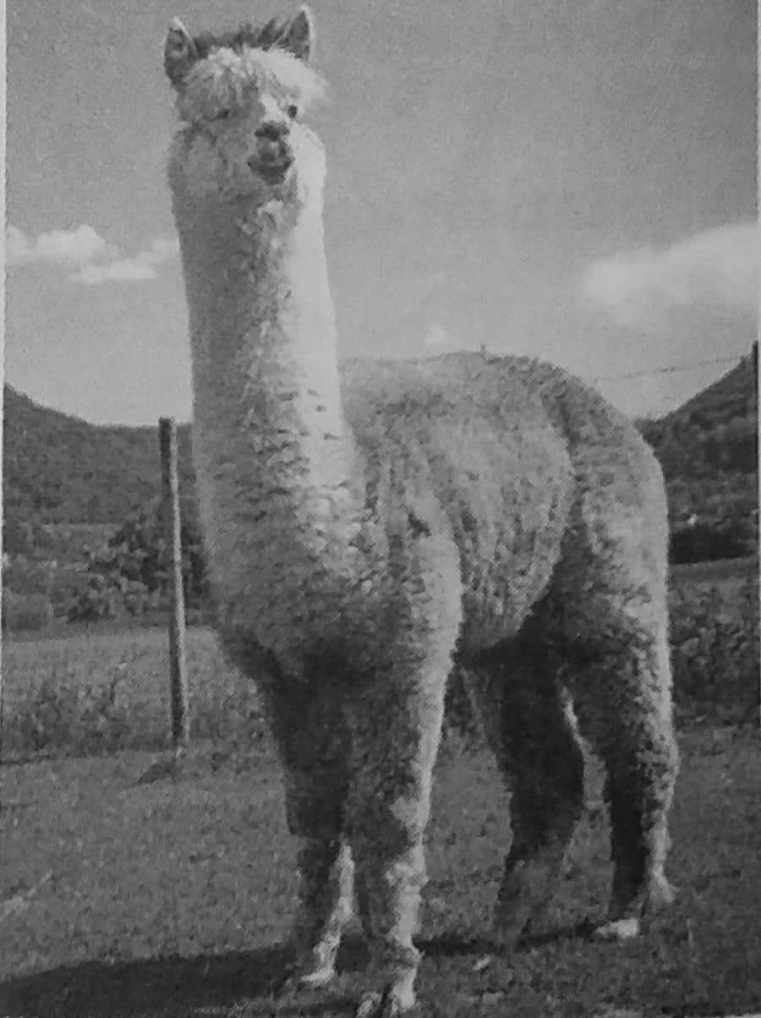

- Identify the animal in the above picture. Where is this animal found in South
America? In what way does the woolly coat of this animal protect it? (2)
- Describe the physical appearance of an animal similar to the one shown above.
What is the importance of this animal? (2)
- In what way is the appearance of The Brazilian Tapir different from the above
animal? (2)

B] With reference to the picture given below, answer the following questions. (6)

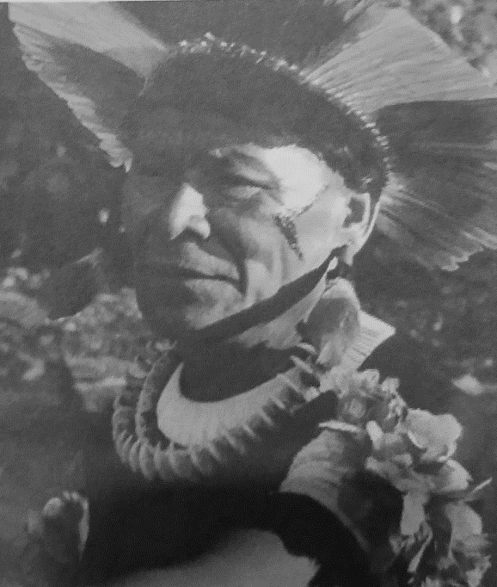

- Identify the individual in the above picture. Where does this individual live in South
America? (1)
- In what way do these individual live a modern lifestyle? (3)
- Describe the two gardens that surround the homes of such individuals. (2)
---------------xxxxxxxxxxx----------------

Std: VI
Date: 11/02/2020

Name: ___________________________________________

Roll No: ____________

Q I] Political Map of South America

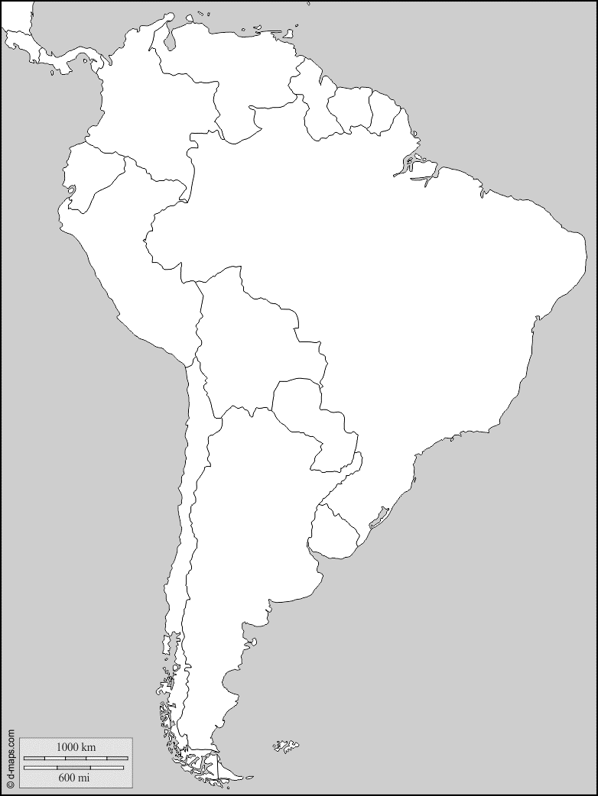

Std: VI
Date: 11/02/2020

Name: ___________________________________________

Roll No: ____________

Q I] Physical Map of South America

