GREENLAWNS SCHOOL, WORLI
FINAL EXAMINATION-2020
HISTORY - CIVICS
Std : VI Marks: 80
Date: 24/2/20 Time: 2 Hrs
1. Read all questions carefully.
2. All questions are compulsory.

Attempt all questions
QI Fill in the blanks: (10)
- Ahimsa or non – violence is the first great teaching of _________.
- Buddha strongly condemned the ________ system and preached that all people are ________.
- The ________ was compiled and the ______ were rewritten during the Gupta era.
- The Mauryans had trade relations with Sri Lanka, _______ and __________.
- _______, the ruler of ______ submitted himself to Alexander without a fight.
- Alexander had ridden _________ into each one of his battles in Greece and Asia.
QII Name the following: (10)
- This sect of Buddhist considered Buddha as God:
- Freedom from the cycle of birth and death:
- The religious literature of the Buddhist is contained in the :
- The ruler that brought political unity and prosperity in northern India during the beginning of the 7th century:
- This temple built by the Gupta ruler is our national heritage:
- The last Mauryan ruler:
- The archaeologist who deciphered an ancient inscription on a stone pillar in Delhi in 1837:
- Mauryan art was greatly influence by this religion:
- Any two regions that Seleucus was compelled to give to Chandragupta:
QIII State whether the following statements are true or false. If false, correct the statement: (10)
- Siddhartha married a beautiful princess called Priyanka:
- The Christians do not agree with the Jain view that inanimate objects like stone, wood etc have life:
- Ashoka appointed officials called mahamatras to carry out political work:
- The Huns decentralized the administration by giving the officials freedom to adminster the territories under their control:
- Samudragupta took the title of Maharajadhiraja and ruled the empire:
- Mantra Parishad were merchants who assisted the Mauryan kings:
- The lion capital was adopted as the national capital of India in 1950:
- Digayush means conquest of territories:
- Ashoka organised the third Buddhist Council at Nandagram to discuss ways of propagating Buddhism:
- Rajaya were the powerful janapadas of the later vedic age:
QIV Answer in a sentence or two: (5)
- Who are the Tirthankaras? (1)
- Who was the last Nanda ruler? How was he as a king? (1)
- Briefly state the layout of the capital city of the Mauryas. (1)
- Why didn’t Samudragupta annex the southern territories of India? (2)
QV Answer the following: (8)
- Briefly explain the similar concepts between the Jains and the Buddhist in relation to God and Ahimsa.
- Why does Ashoka occupies a unique place in the history of human civilization?
- How did the spies of the Mauryan kingdom help in kings in the smooth running of the empire?
- What led to the economic growth and prosperity of the Gupta Empire during the reign of Chandragupta II?
QVI Give reasons for the following: (6)
- The Gupta’s were far advanced in the field of metallurgy.
- Chandragupta’s success was largely due to the guidance and training of his advisor Chanakya.
QVII With reference to the picture given below, answer the questions that follow: (6)
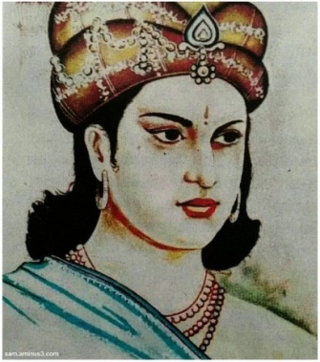
- Identify the ruler in the given picture and the empire to which he belonged?(1)
- Why did this ruler want to capture Kalinga? (2)
- What were the main principles of Dhamma that the people had to follow according to this ruler? (3) CIVICS SECTION
QVIII Fill in the blanks: (10)
- There are many small ________ and ______ yet almost 74% of India's population lives in the villages.
- Social barriers like ________ barriers and ________ have to be removed from the villages.
- The ________ government and the ______ ___ governing bodies usually cooperate with each other to carry out their duties.
- It is clear that the _______ conditions of the people who live in cities and villages are at great variance.
- The _______ and ______ of trade has seen the emergence of cities in the past.
QIX State whether the following statements are true or false. If false, correct the statement: (5)
- Trade is also called the primary sector of the economy:
- The percentage of the people unemployed in the cities is more than the people in the cities:
- Port Trust is the local self governing body in a large city:
- The Improvement trust sets up a number of committees to look after the day to day work of the Municipality:
- A Municipal Corporation is elected for a period of one year:
QX Answer the following: (5)
- Name the three categories of working population found in our country. (3)
- What are the two Compulsory Functions in the Public Health zones which are taken care by the Municipal Corporation? (2)
QXI With reference to the picture given below, answer the questions that follow (5)

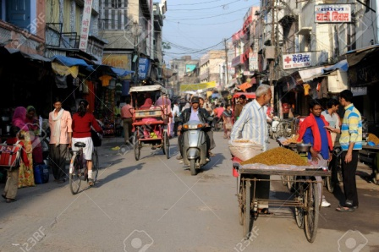

1. Why were the conditions of the people worse in villages during the British rule in India? (1)
2. Mention any two problems which are still faced by the people, in villages of our country. (1)
3. Who introduced the Zamindari System? Why was this system a curse to the Indian Economy? (3)

**********************

