GREENLAWNS SCHOOL, WORLI
FINAL EXAMINATION-2020
HISTORY - CIVICS
Std : VII Marks: 80
Date: 20/2/20 Time: 2 Hrs
1. Read all questions carefully.
2. All questions are compulsory.

QI Fill in the blanks: (10)
- Krishnadevaraya encouraged foreign trade with the _________ who had established trade centres on the _________ Coast.
- During 1528, ______ was a Rajput stronghold in _______ under Medini Rai.
- Akbar turned his attention to the Deccan and by 1601 he annexed _____, ___________ and parts of Ahmadnagar.
- After the death of Raja Ram’s death, the leadership of the ________ resistance passed to his brave and capable widow ______.
- During the 7th century, people were attracted to the principles of ______, equality and ________ free worship.
QII Name the following: (10)
- The officials who governed the villages at the bottom rung of the administrative ladder in the Vijaynagar kingdom :
- The ruler of Gujrat of Malwa whose aim was to capture Delhi and become the emperor of India during the 15th century:
- The supervisor of the royal household during Akbar’s reign was :
- Provinces into which Akbar’s empire was divided:
- The most impressive building in the Red Fort:
- Nur Jahan’s original name was :
- The belief that there is only one god:
- This movement arose as a reaction and response to the trends in the Muslim society:
- Salim ascended the throne under the title of :
- Smaller units of administration during Akbar’s reign:
QIII State whether the following statements are true or false. If false, correct the statement: (10)
- The death of the Alauddin Hassan signalled the end of the Bahmani kingdom:
- With the help of Mohamd bin Quasim Humayun returned and recovered Kabul and Kandhar from his brother Kamran:
- According to Mri Sanam there were 36 top – ranking musicians in Akbar’s court:
- Raja Mansingh was made Hindi Kavi Raj in Akbar’s court:
- The word Bhakti means prudence to ones God:
- The first Bhakti preacher in Maharashtra was Tukoba:
- The Jami Masjid at the Agra Fort is considered to be the most perfect of Shah Jahan’s building:
- Sarangi was the standard silver coin introduced by Sher Shah:
- The Bahamani rulers patronized Hinduism:
- Krishnadeveraya was a fine Tamil poet and a Sanskrit scholar as well:
QIV Answer in a sentence of two: (5)
- Name the most outstanding building built by the Bahmani Kings.
- What was the use of the Stone screens used during the Mughal era?
- Name two of Akbar’s courters who refused to follow Din – i – Iiahi.
- Define Jauhar.
- What was the perennial bone of connection between the Vijaynagar and the Bahamani kingdom.
QV Answer the following questions: (8)
- How did the middle and the upper middle class get an access to the common literature and an insight into various cultures? (2)
- How did Akbar treat the Rajput kings after defeating them in war? (2)
- ‘The Vijayangar Society believed in a rigid caste system.’ Justify the statement. (3)
QVI Give reasons for the following facts: (6)
- The emperor was an extremely powerful figure during Akbars reign.
- Nur Jahan became the power behind the Mughal throne during Jahangir’s reign.
QVII With reference to the picture given below, answer the questions that follow: (6)
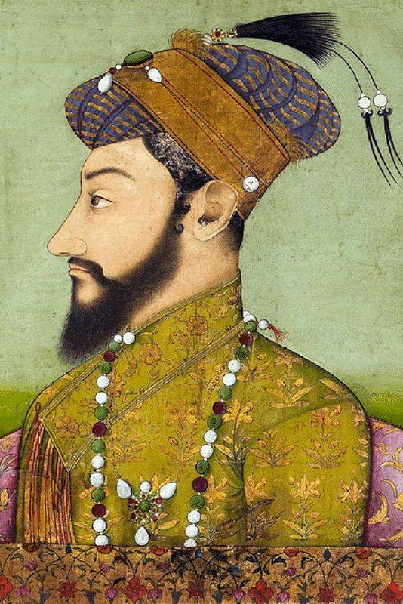
- Identify the ruler in the given picture. List the extent of his Empire in 1690. (2)
- Mention any 4 consequences that were borne by the Mughal Empire due to long years of struggle with the Marathas. (4)

CIVICS SECTION
QVIII Fill in the blanks: (10)
- The _______ Principles have been inspired by the Constitution of ________ and also by the Gsndhian Principles,
- During the freedom movement, ________ had worked out a plan for _____ development. 112
- The constitution of India has an ________ or formal statement which gives the _________ of the constitution.
- Equality means all the citizens would be able to make full use of their talent without any ________ and ________.
- India does not have a ________ head, the head is elected for a fixed term, is just a ________ head.
QIX State whether the following statements are true or false. If false, correct the statement: (5)
- A decent standard of living and leisure is a General Principle:
- Needs that a person has because of mental or physical problems are called variable needs:
- India is a welfare country:
- Reunion means common brotherhood assuring unity, dignity and integrity:
- The High court tells us that India is a sovereign country free from external control:
QX Answer the following questions: (5)
- What is the common purpose of the Fundamental Rights and the Directive Principles?
- Mention any three features to prove that India is a Socialist country.
QXI With reference to the Preamble of India, answer the questions that follow: (5)
- Enumerate any two features of the term Republic.
- What are the ideals of Justice in the India?

*****************

