GREENLAWNS SCHOOL, WORLI
TERMINAL EXAMINATION - 2019
HISTORY / CIVICS

Std: VII Marks: 80
Date: 23/9/19 Time: 2hrs
Attempt all questions
QI Fill in the blanks: (10)
- North – Indian or ___________ music was the outcome of the fusion of the _____________ and the Indian classical music styles.
- Padmini the queen of ___________ of ___________ was famous for her beauty.
- In 1320 CE the last Khilji ruler was killed by___________.
- The attack on the __________ in __________ was Mahmud’s most ambitious and profitable expedition.
- ___________ means that the king is considered a representative of God on earth.
- The Turks were originally ________ tribes who adopted _______ as their religion.
QII Name the following: (10)
- Two groups of the priestly class during the Sultanate period:
- Two good qualities of Alauddin Khilji as a ruler:
- Two places recovered by Rana of Mewar to build a powerful kingdom in Rajasthan:
- Two names of the famous brother of Ghaiyasuddin Ghori:
- Two designs found on the monuments of the Sultanate periods:
QIII State whether the following statements are true or false. If false, correct the statement: (10)
- The Afghans brought with them Arabic and Persian architectural styles:
- Amir Khusrau is very closely associated with the history of Mughal music:
- Muhammad Ali was the first ruler of the Sayyid dynasty:
- Alauddin sent an expedition to Gujarat which was conquered and annexed and Salim Shah, a slave was bought for 1000 dinars:
- Sultan Mahmud drained away India’s vast treasures and used to transform Persia into a magnificent capital city:
- Raja Jaichand assumed control of Muhammad Ghori’s Indian possessions and laif the foundation of the Delhi Sultanate:
- Razia Sultan is said to have fallen in love with her Turkish slave, Yakut:
- Salamat is the Muslim calendar which begins from the year 622 CE:
- The Sultans established several trade settlements on the western coast of India around the 8th century CE:
- Mecca was the town in Arabia where Prophet Muhammad was born:
- The control of the Lodis was confined to Punjab and the Doab areas:
QIV Answer in one line only: (5)
- Why was the aristocracy the most powerful social group during the Sultanate period?
- What necessitated Muhammad bin Tughlaq to conquer the areas between Ganga and Yamuna rivers?
- Who nominated Firoze Shah Tughlaq as the next ruler of the Sultanate period?
- What is Kathak?
- What were the different kinds of torture that were been given to the suspected criminals during the reign of Firoze Shah Tughlaq?

QV Answer the following: (2 mks each) (8)
- How were the corrupt merchants treated during the reign of Alauddin Khilji?
- What means were used by Alauddin to proclaim himself the Sultan of Delhi?
- Why is Firoze Shah Tughlaq fondly remembered in Indian History?
- How did Firoze Shah Tughlaq promote education and learning?

QVI Give reasons for the following: (6)
- Many Hindus got converted during the Sultanate period to Islam.
- Firoze Shah was kind and merciful.

QVII With reference to the picture given below, answer the questions that follow: (8)
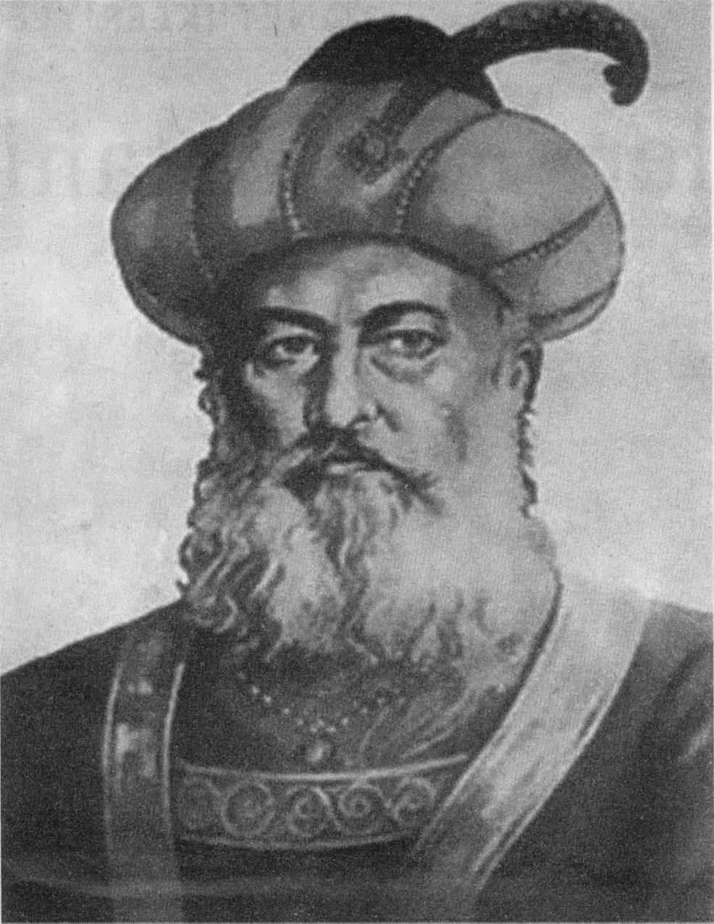
- Identify the ruler in the given picture. (1)
- How did the ruler use the vast wealth which he drained away from India? (1)
- ‘Jaipal burnt himself to death.’ Give reasons. (3)
- What measures did Balban take to strengthen his defences against the Mongol Invasion? (3)

CIVICS SECTION
QVIII Fill in the blanks: (10)
- The saffron colour symbolizes ________, sacrifice and _________.
- The voting power of all the elected members of the _________ is made equal to the voting power of all the elected members of the _____ _______ in the country.
- The Chakra in our National Flag has been adopted from the ____ _______ at _________.
- Every free and independent nation adopts a National _________ that serves as an official __________ and appears in Stamps.
- The ___________ can make rules and issue orders for the smooth functioning of the ______________ .
QIX State whether the following statements are true or false. If false, correct the statement: (4)
- The great patriotic song Sare Jahan Se Acha is our National song:
- The inscription Humara Bharat supports the basic philosophy of Indian culture that is truth should rule over the evil:
- Ours is a Presidential form of government in which the President is only a titular head of the state:
- The Council of Ministers advises the President to summon, prorogue or dissolve the Lok Sabha:

QX Answer the following: (5)
- What is a Republic State? (1)
- How should our National Flag should be hoisted? (1½)
- Define the term ‘Sovereign’. (2½)

QXI With reference to the picture given below, answer the questions that follow: (5)
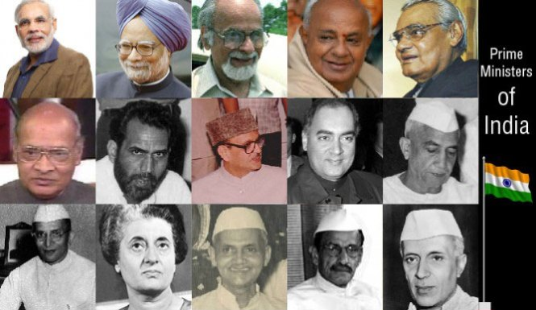
- When can a non member of the Parliament be appointed by the Prime Minister? (1½)
- Who forms the Political executive at the centre? (1½)
- How can the President of our country be impeached according to Article 61? (2)

*************

