GREENLAWNS SCHOOL, WORLI
TERMINAL EXAMINATION - 2019
HISTORY / CIVICS
Std: VI Marks: 80
Date: 20/9/19 Time: 2 Hrs
Attempt all questions
QI Fill in the blanks: (10)
- Caste was not decided by ______ and not by _______ during the Early Vedic Age.
- The word Hindu comes from the word Sindhu, the ____ term for the river _______.
- The history of _______ during this period is based mainly on the ________ which was composed during the Early Vedic Age.
- Another important feature of Chinese architecture was the construction of ______ style temples known as ________.
- About 3200 BCE the Egyptians were united and ruled by _______ to become a brilliant civilization and lasted until the death of _____ the last pharaoh in 30 BC.
QII Name the following: (10)
- The sermon given by the two warriors in the battlefield of Kurushetra:
- Two councils that exercised control over the king during the early Vedic age:
- Two outdoor activities enjoyed by the Aryans:
- Metal workers produced weapons and other subjects of:
- Large elaborate structures with pillared halls and fancy decorations:
QIII State whether the following statements are true or false. If false, correct the statement: (10)
- Rama was married to Sita, the daughter of King of Virata of Surat:
- Sujarta were the warriors who protected the tribe from outside attacks:
- The king ruled according to the wishes of the ministers:
- A widely prevalent practice of the Chinese was the hawk practice:
- Vaya was the Egyptian god of death :
QIV Answer in a sentence or two: (5)
- What are Epics?
- Who were the Shudras?
- Mention any two animals domesticated by the Chinese.
- Who was Ptolemy?
QV Answer the following: (8)
- What is the basic principle of Hinduism?
- ‘The early Vedic people seem to have known about agriculture.’ Justify.
- What did Confucius teach his disciples about life?
- How did the river Nile in facilitating trade?
QVI Give reasons for the following: (6)
- The chief occupation of the Egyptians was agriculture.
- The basic pattern of all the houses of the Chinese civilization was the same.
QVII With reference to the picture given below, answer the questions that follow: (6)
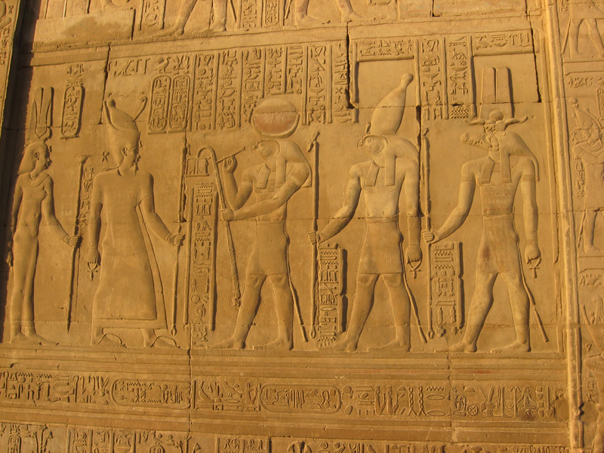
- What does the above picture depict? (1)
- How were women treated in this civilization? (2)
- ‘Medicine was far advanced in this civilization’. Justify the given statement by giving appropriate examples to support your answer. (3)

CIVICS SECTION
QVIII Fill in the blanks: (10)
- Local self – government lies at the _____ of the _______ pyramid and functions at the grassroots level.
- The new market _______ and social mobility have led to relocation of ________ groups to different parts of the country.
- The _______ and ________ revolution has changed forever traditional concepts and modes of communication.
- After ________ the Panchayati Raj system was revived by the _____ government.
- The Zila Parishad encourages _______ as well as _____ – _____.
QIX State whether the following statements are true or false. If false, correct the statement: (5)
- India is divided into a number of states.
- Each religious community has certain specific family traits that distinguish it from other religious communities:
- The sarpanch assists the villagers in dealing with day – to – day problems:
- The TV industry has brought distant countries and continents into our living rooms:
- The spirit of hospitality is essentially a collective, group memory of past achievements, traditions and experiences:
- The nyaya panchayat tries petty civil and criminal cases:
QX Answer the following: (5)
- Who heads the panchayati raj system? (1)
- When does the gram sabha holds its meetings? (1)
- Mention any two district officers who are elected in the composition of zila parishad. (1)
- Define’ Regional communities.’ (2)
QXI With reference to the pictures given below, answer the questions that follow: (5)
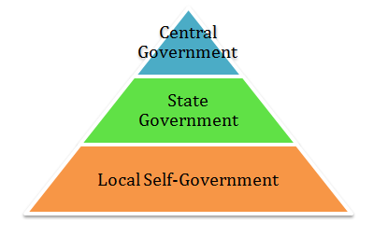
- What is the responsibility of the State Governments towards our country? (2)
- Other than the Community development programmes, what are the functions of the Block Samiti? (2)
- Define ‘The Panchayati Raj System.’ (1)

**********************

