GREENLAWNS SCHOOL, WORLI

FINAL EXAMINATION

MATHEMATICS

STD: VI MARKS: 80

DATE: 18/02/2020 TIMES: 2½ hrs

**Section A**

**(Attempt all questions of this section)**

**Question 1**

1. Numeral co-efficient of – 35 x2 y2 z2 ________________________________________ **[1]**
2. Perimeter of a ________________________ = 2 ( length + breadth) **[1]**
3. Perimeter of equilateral triangle is _______________________ **[1]**
4. The constant term in the expression - 4xyz + 7 is ____________________ **[1]**
5. The number of terms in the expression – 2xyz + 5y **÷** 2 __________________ **[1]**
6. Area of a square with side 10 cm = __________________________________ **[1]**
7. Area of rectangle whose length and breadth are 16 cm and 1 cm respectively is____ __________________ **[1]**
8. If perimeter of a regular pentagon is 10 cm, then its side = ________________ cm. **[1]**
9. If perimeter of a square is 40 cm, then its side = ________________ cm. **[1]**
10. Number of sides of a regular polygon with each exterior angle 36˚ is ___________ **[1]**

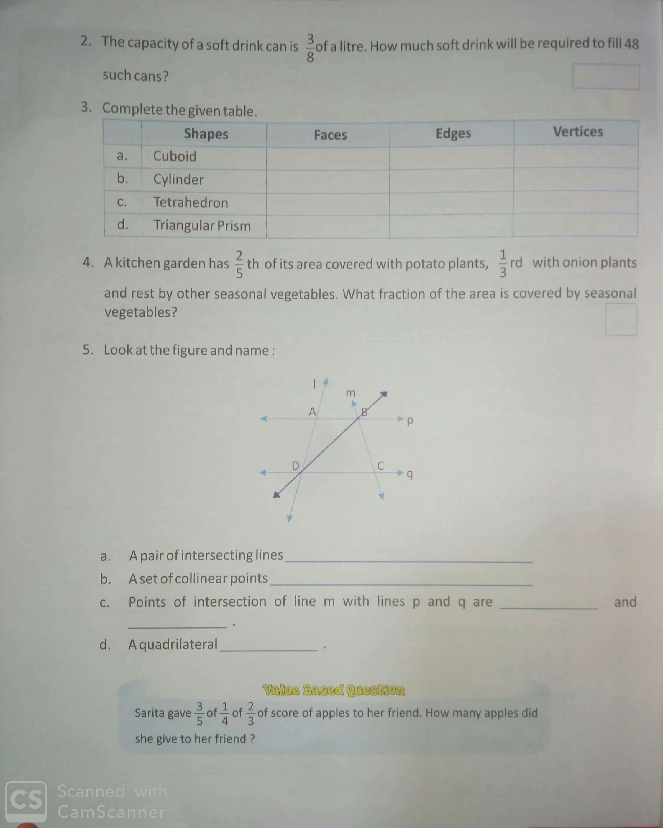**Question 2**

1. Look at the figure and name [3]

i. Pair of intersecting lines ______________________

ii. A set of collinear points ______________________

iii. A set of concurrent lines _______________________

1. . Name the types of following triangles. **[3]**
2. ∆ABC with ∟B = 90˚ _________________
3. ∆XYZ with ∟X = 30 , ∟Y = 70 and ∟Z = 80. _____________
4. **∆**ABC with DE = 7.6 cm , EF = 6 cm and DF = 6 cm ____________
5. Identify the following as monomial, binomial trinomial and polynomial. **[3]**
6. 5x + 3y – 1 ______________________
7. 2xy +3yz + 5xz + 8 _________________
8. – 3a X 5a ________________________

1. From the sum of 762 and - 857, subtract the sum of - 491 and 685 **[3]**

________________________________________________________________________________________________________________________________________________________________________________________________________________________

1. Simplify: (- x2 + y2 + 2xy – 1) – (x2 + y2 + 4xy + 5). **[3]**

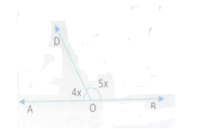________________________________________________________________________________________________________________________________________________________________________________________________________________________________________________________________________________________________

**Question 3**

1. Find the value of x , and also find measure of ∟AOD and ∟DOB **[4]**

_____________________________________________________

_____________________________________________________

_____________________________________________________

1. Identify the pair of angles in each of the figure given as adjacent angles , vertically opposite angles , interior alternate angles , corresponding angles , Co- interior angles or exterior alternate angles. **[5]**
2. ∟2 and ∟4 ­­­­­­­­­­­­­­­­­­­­____________________
3. ∟1 and ∟8­­­­­­­­­­­­­­­­­­­­____________________
4. ∟4 and ∟5 ­­­­­­­­­­­­­­­­­­­­____________________
5. ∟1 and ∟5 ­­­­­­­­­­­­­­­­­­­­____________________
6. ∟3 and ∟5 ­­­­­­­­­­­­­­­­­­­­____________________
7. From the figure identify. **[6]**
8. 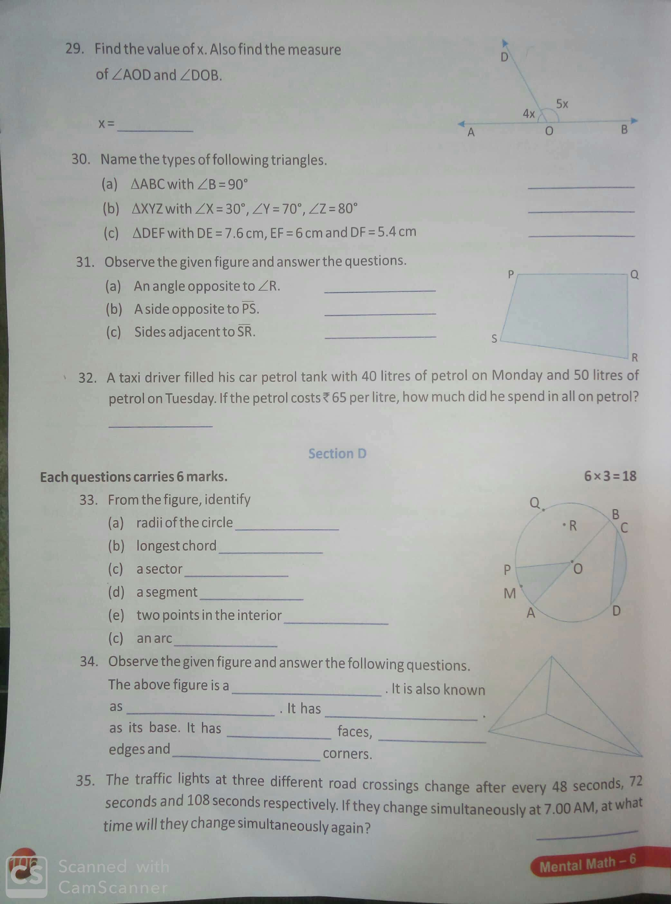Radii of circle ________________
9. Longest chord _______________
10. A segment __________________
11. A sector ____________________
12. Two points in the interior _________________
13. An arc _____________________

**Section B**

**(Attempt all questions of this section)**

**Question 4**

1. A 160 m long train is travelling at a speed of 36 km h-1 , find the time taken by the train to pass :
2. A telegram post and ii. A 100 m long platform **[3]**
3. Find the product of : (5x – 6y – 7z) and (2x + 3y) **[3]**
4. Simplify : -17 – [ -10 + 13 – (-6) ] **[2]**
5. Solve for x: 3x + 2 = 11 **[2]**

**Question 5**

1. Divide : 15 x2y3 – 21x3y4 + 18 x4y2 by 3 x2y2 **[3]**
2. Solve : 3(2x + 1) – 2(x – 5) – 5(5 – 2x) = 16 **[3]**
3. The sum of three consecutive numbers is 54. Taking the middle number as x , find
4. Expression for the smallest and largest number.
5. The three numbers. **[4]**

**Question 6**

1. Find the number of sides of polygon, if the sum of its interior angles is 1800˚. And also find measure of its each interior angle. **[3]**
2. Squarer shaped tiles of side 50 cm are to be fixed in a hall of dimensions 4.4 m and 8 m. find the number of tiles required. **[3]**
3. Construct a triangle XYZ with, ZY = 5.4 cm, ∟A = 30˚ and ∟B = 90˚. Draw the circumcircle of the triangle **[4]**

**Question 7**

1. Find the mean and the median of: 5, 8, 10, 11, 13, 16, 19, and 20. **[3]**
2. Draw a line segment YZ = 6 cm locate point X which is at a distance of 6 cm from X and 6 cm from Z. Through the point W, draw a perpendicular on to the line segment XY. **[3]**
3. Simplify: 3x – ( 2x – x + 2) **[2]**
4. Find the complement and supplement angle of 49˚ **[2]**

*************