GREENLAWNS SCHOOL, WORLI
FINAL EXAMINATION-2020
SCIENCE
STD: VI TIME: 2hr
Date: 13/02/2020 MARKS: 80
Attempt all questions.
QI A. Fill in the blanks: [5]
- Pure substances are made up of only one kind of __________.
- SI unit of pressure is ______________.
- ____________ was found in Magnesia and is a natural magnet.
- _________ is the transfer of pollen grains from the stamen to the stigma of a flower.
- Cuts and bruises can cause ________________.

QIB State whether the following statements are true or false. Correct the false statements: [5]
- The heavy solid particles that get deposited at the bottom of the container is called filtrate.
- Fruits and vegetables decompose and produce good quality manure.
- Grape plants have modified leaves called spines to help them to seek support.
- Wear and tear of the shoe sole is caused by friction.
- Soda water and water molecular formulae is H₂CO₃.

QIC Choose the correct answer and rewrite the statement: [3]
- Which of the following term is a synonymous with ‘push and pull’?

- Speed iii Mass
- Force iv Pressure

- Which of the following is used to find direction?
i Iron nail iii Magnetic compass
ii Magnetic Keeper iv Both (ii) and (iii)
- __________ is a diatomic element.
I Boron iii Ozone
ii Phosphorus iv Oxygen
- Which of these is a simple leaf?
I Date iii Apple
ii Gram iv None of them
- Which of these contain fats?
- Potato iii Sugar
ii Butter iv Bread

- A centrifuge machine may be operated ___________.
I Manually iii Naturally
ii Electrically iv Both (i) and (ii)

QID Find the odd one out. Give a reason to support your answer: [4]
- Scurvy; Night blindness; Conjunctivitis; Rickets
- Tap root; Primary root; Stilt root; Prop root
- Shaving blade; cobalt; steel knife; Books
- Grooves; Spikes; Dots; Rubber grip

QIE Name the following: [6]
- The Latin name for silver.
- Any one use of a magnet to store sound
- A lubricating agent to reduce friction
- The point on a stem where a single leaf arises.
- Any one pollutant given out by automobiles
- The technique used in salt pans to obtain salt.

QIF Give the symbols for the following element: [1]
- Potassium ___________
- Magnesium _________________

QIG Give the common name for the following compounds: [2]
- Sodium Carbonate _____________
- Acetic acid ____________________

QII Define the following terms: [6]
- Magnetic field d. Communicable disease
- Pressure e. Winnowing
- Compound f. Phyllotaxy

QIII Distinguish between the following; [Any two points] [10]
- Calyx and Corolla
- Vector disease and Contagious diseases
- Muscular force and electrostatic force
- Sedimentation and Decantation
- Directive property and Attractive property

QIV Answer the following questions:
- What are magnetic keepers? How are they used? [2]
- Give any two advantages of distillation. [2]
- How does friction have an effect in our daily life? (state any two ways) [2]
- How would you treat a burn injury? [2]
- Mention any two functions of a flower. [2]

QV Give scientific reasons for the following:
- The iron nail behaves as a temporary magnet [2]
- A mixture retains its properties of its constituent elements. [2]
- Though it is difficult to push a heavy box the task becomes easier when wheels are attached. [2]
- Water is an example of a compound. [2]

QVI A Observe the diagram carefully and answer the questions that follow:
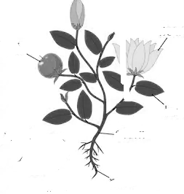
a. Name the two systems of the plant. [1]
- Label parts (a), (b) and (c)and explain them. [3]
- What is part (e)? State any one function of it. [1]
- List any two characteristics of part (d). [2]
B With reference to the given diagram answer the questions that follow:
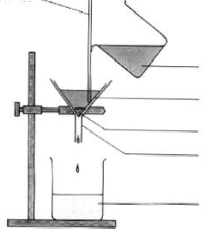

a. Label the marked parts ‘a’ to ‘e’. [2 ½ ]
b. State the function of ‘b’. [1]
c. How does ‘c’ help? [ ½ ]
d Give one example of a similar method used in our homes.. [1]
C Solve the following:
a. Calculate the pressure exerted by a force of 300N acting on an area of 30 cm². [1½]
b. What is the pressure exerted by a box if it exerts 480 kgf and has a base dimension 1m X 1.5m. [Assume 1kgf = 10 N] [2 ½]
D Draw a neat labelled diagram to show magnetism by double touch method. [2]
E Draw a neat labelled diagram of a First Aid box and show any four components that it contains. [2]
*******************

